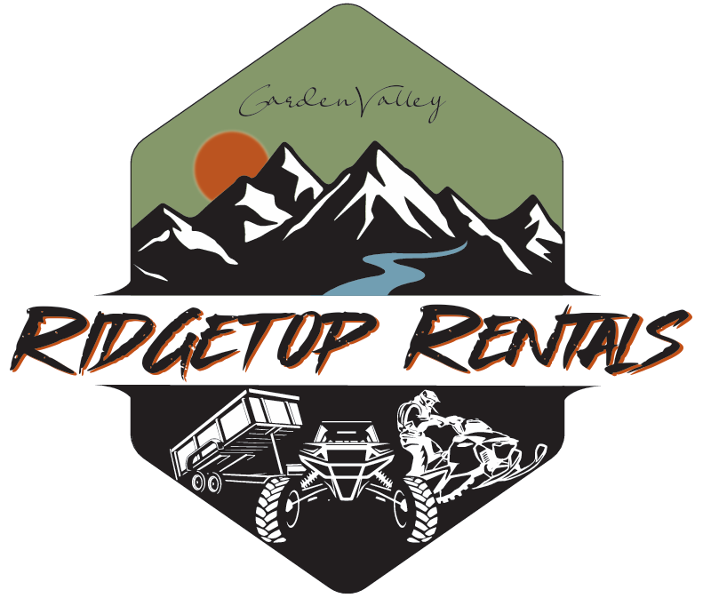

**Rental, Indemnity and Warranties:** This is a contract for the rental of the equipment for the agreed period of time represented in the rental confirmation. You agree to indemnify us, defend us and hold us harmless from all claims, liability, costs and attorney fees we incur resulting from, or arising out of this rental agreement and your use of the equipment, including personal injury to you and/or your passengers. We make no warranties, express, implied, or apparent, regarding the rented item(s).

**Insurance:** You are responsible for all damage or loss you cause to others. You agree to provide liability, collision and comprehensive insurance covering you, us, and the equipment.

**Damage hold**: You will allow a damage hold for each item rented. Damage hold(s) will be held on your credit card on the rental start date. We may use your damage hold and bill your credit card to pay any amounts owed to us under this agreement including but not limited to damages caused and rental days equipment is out of rental inventory. Your hold will be returned to you, less damage, late, and/or cleaning fees, within 14 days of the return date.

**Operation Instructions:** You agree that you have received operation instructions for the equipment.

**Limitations of Use**: With respect to the operation of the equipment during the rental period, you agree, represent, and warrant the following: a. That no person other than driver/operator shall operate the equipment unless such person is listed as an additional authorized driver/operator on the rental agreement. b. That you shall not operate the equipment in a willful disregard for the safety of the persons or property in a manner that might endanger the life or limb of any person or any property. c. That all passengers and operators will wear a helmet while operating or riding on the applicable equipment and obey all speed limits and other appropriate local laws.

**Renter agrees that:** I am completely financially responsible for any and all damages that occur during the time and date rented out until the equipment is returned and checked over completely by an authorized employee to Garden Valley Ridgetop Rentals in satisfactory condition. I understand that I am financially responsible for any and all damages to items that I am renting, using, or borrowing from Garden Valley Ridgetop Rentals or any of its employees.

I understand that any tampering with any part of the rented equipment or other item(s) rented is completely prohibited. If any tampering is found to be done to rented equipment during rental period whether you did it or not you are completely responsible.

Rental period is defined as being from the time the renter signs this Agreement to the time the equipment is checked in by a Garden Valley Ridgetop Rental representative.

All damages must be paid for immediately by renter.

I agree that all authorized drivers of the rented equipment be at least 18 years of age minimum. I agree that all drivers/passengers will wear appropriate gear at all times. I understand, accept, and assume all responsibility for any person riding/ using/ participating with the applicable item(s). I hereby release Garden Valley Ridgetop Rentals of any financial liability or any other type of responsibility for any injuries or accidents that occur during the rental period. I agree to stay on marked roads at all times and will not litter at any time. I understand that I am completely responsible for any tickets or citations received during the rental period. I agree that all drivers and/or users of the rented items will drive and use in a safe responsible manner and obey all rules.

**Recreational Activity Release of Liability, Waiver of Claims, Express Assumptions of Risks and Indemnity Agreement Express Assumptions of Risk Associated with Recreational Activities:**

I do hereby affirm and acknowledge that I have been fully informed of the inherent hazards and risks associated with any recreational activity from general operating and including the rental of equipment and transportation.

**Inherent hazards and risks included but are not limited to the following:**

1. Risk of injury from the equipment is significant including the potential for permanent disability and/or death to renter and/or participant and/or bystander.

2. Possible equipment failure and/or malfunction of my own or other’s equipment.

3. This activity takes place outdoors and therefore includes risks associated with exposure to elements, heat, hypothermia, impact of the body on the ground and encountering objects either natural or man-made causing pain, injury and/or death.

4. My own negligence and/or the negligence of others, including but not limited to operator error and decision making.

5. Accidents or illness occurring in remote places where there are no available medical facilities.

6. Fatigue, chill, and/or dizziness, which may diminish my/our reaction time and increase the risk of accidents.

**Note:** I understand the description of these risks are not complete, and that unknown or unanticipated risks may result in injury, illness, pain or death.

**I hereby release of Liability, Waiver of Claims, and Indemnity Agreement In consideration for being permitted to participate in the activity and related activities, I hereby agree, acknowledge that:** I HEREBY RELEASE AND HOLD HARMLESS WITH RESPECT TO ANY AND ALL INJURY, DISABILITY, DEATH, or loss or damage to person or property, WHETHER CAUSED BY NEGLIGENCE OR OTHERWISE, the following named persons or entities, herein to as releases Garden Valley Ridgetop Rentals and it’s officers, directors, employees, owners, representatives and agents from liability whatsoever and for any claims or causes or action that I, my estate, heirs, survivors, executors, or assigns may have for personal injury, property damage, or wrongful death arising from the above activities whether caused by active or passive negligence of the release or otherwise.

By executing this document and Agreement, I agree to hold the releases harmless and indemnify therein in conjunction with any injury, disability, death, or loss or damage to person or property that may occur as a result of engaging in the above activities.

By entering into this Agreement, I am not relying on any oral or written representation or statements made by the releases, other than what is set forth in this Agreement. This shall be binding to the fullest extent permitted by law. If any provision of this release is found to be unenforceable, the remaining terms shall be enforced.

**I HAVE READ THIS RELEASE OF LIABILITY AND ASSUMPTION OF RISK AGREEMENT, AND I FULLY UNDERSTAND ITS TERMS, AND UNDERSTAND THAT I HAVE GIVEN UP LEGAL RIGHTS BY SIGNING IT, AND I SIGN IT FREELY AND VOLUNTARILY WITHOUT ANY INDUCEMENT.**

**DECLARATION OF FITNESS TO OPERATE**:  I hereby declare that I am physically fit. I do not, and have not, suffered from any physical or mental condition or am under the influence of alcohol or drugs that would limit my operation of the equipment in a safe and lawful manner.