Cavanal Chiropractic Clinic
Shady Point, OK

HOW CAN WE HELP YOU?

What brings you in today?
__________________________________________________________________________
__________________________________________________________________________
__________________________________________________________________________
__________________________________________________________________________

If you are experiencing symptoms, how intense are your symptoms?
□ □ □ □ □ □ □ □ □ □ □
0 1 2 3 4 5 6 7 8 9 10
NO MILD MODERATE SEVERE
SYMPTOMS SYMPTOMS SYMPTOMS SYMPTOMS

What do your symptoms feel like? (check where appropriate)

- Numbness | - Burning | - Swelling
- Tingling | - Cramping | - Throbbing
- Stiffness | - Nagging | - Stabbing
- Dull | - Sharp | - Other ______________
- Aching | - Shooting | ______________________

How long have you had these symptoms?______________________________________
__________________________________________________________________________
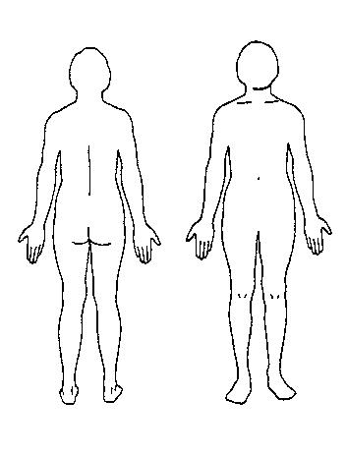
Are your symptoms interfering with your life in any
of the following areas?

□ YES □ NO Work
□ YES □ NO Exercise
□ YES □ NO Recreation
□ YES □ NO Sleep
□ YES □ NO Self-Care
□ YES □ NO Energy
□ YES □ NO Attitude
□ YES □ NO Patience
□ YES □ NO Productivity
□ YES □ NO Creativity
□ YES □ NO Other____________________

On the drawings, circle the areas on your body
where you have pain or other symptoms.
ILLNESS-WELLNESS CONTINUUM

Tell us how you are feeling. On this scale of 0-10, check what number you think represents your overall health today.

□ □ □ □ □ □ □ □ □ □ □
0 1 2 3 4 5 6 7 8 9 10
DISEASE POOR HEALTH NEUTRAL GOOD HEALTH PERFECT HEALTH

HEALTH & ILLNESS HISTORY

- AIDS/HIV | - Depression | - Multiple Sclerosis
- Alcoholism | - Diabetes | - Neck Pain
- Anxiety | - Digestive Issues | - Reproductive Issues
- Arteriosclerosis | - Elbow/Wrist/Hand Pain | - Ringing in Ears
- Arthritis | - Foot/Ankles Issues | - Scoliosis
- Asthma/Allergies | - Gout | - Shoulder Issues
- Back Pain | - Headaches/Migraine | - Stroke
- Cardiovascular Issues | - Heart Disease | - TMJ Issues
- Cancer | - Hepatitis | - Urinary Issues
- Circulation Issues | - Hip Issues | - Osteoporosis
- Childhood Illness | - Lymphatic Issues | - Other____________

CHILDREN & PREGNANCY

How many children do you have?________ Children’s ages?______________________

Number of past pregnancies?___________

Are you currently pregnant?____________, Due date_________

Health concerns regarding this pregnancy?_____________________________________

Is there any other information about your health you would like the Doctor to know?
__________________________________________________________________________________________________________________________________________________________________________________________________________________________________________________________________________________________________________________________________________________________________________________

Do you have any questions or concerns about chiropractic care?

__________________________________________________________________________
__________________________________________________________________________
__________________________________________________________________________

