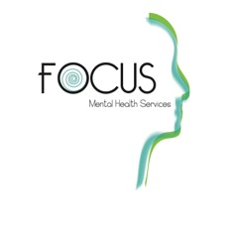
Focus Mental Health Services
905 E. Wilson St., Shawnee, OK 74804
405-214-0116
www.focusmhs.com

Sliding Fee Discount Application

It is the policy of Focus Mental Health Services to provide essential services regardless of the patient’s ability to pay. Discounts are offered based on family size and annual income. Please complete the following information and return to the front desk to determine if you or members of your family are eligible for a discount.

The discount will apply to all services received at this clinic, but not those services that are purchased from outside, such as medication management, psychological testing, and other such services. This form must be completed every 12 months or if your financial situation changes.

NAME OF HEAD OF HOUSEHOLD |  |  | PLACE OF EMPLOYMENT
STREET | CITY | STATE | ZIP | PHONE

Please list spouse and dependents under age 18.

Name Date of Birth Name Date of Birth
SELF |  | DEPENDENT
SPOUSE |  | DEPENDENT
DEPENDENT |  | DEPENDENT
DEPENDENT |  | DEPENDENT

Annual Household Income

Source Self Spouse Other Total
Gross wages, salaries, tips, etc.
Income from business, self-employment, and dependents
Unemployment compensation, workers' compensation, Social Security, Supplemental Security Income, public assistance, veterans' payments, survivor benefits, pension or retirement income
Interest, dividends, rents, royalties, income from estates, trusts, educational assistance, alimony, child support, assistance from outside the household, and other miscellaneous sources
Total Income
NOTE: Copies of tax returns, pay stubs, or other information verifying income may be required before a discount is approved.
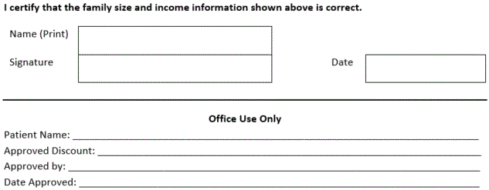
Verification Checklist Yes No
Identification/Address: Driver’s license, utility bill, employment ID, or other
Income: Prior year tax return, three most recent pay stubs, or other
Insurance: Insurance Cards

