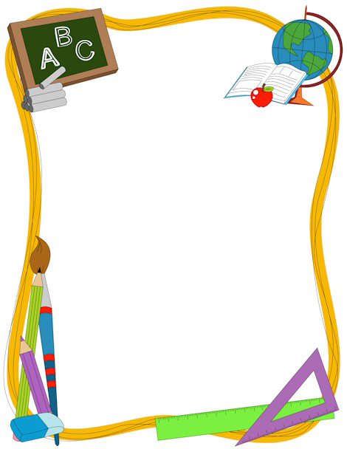**Welcome to 5th Grade!**

**Supply list for**

**2024/2025 school year:**

* **1** book bag/backpack (no wheels…for safety reasons)
* **1**-1”binder (3 ring)
* **1** 2” binder (3 ring)
* **1** pack binder dividers
* **4** plastic folders with holes to keep in 3 ring binder – 1 red, 1 blue, 1 green, 1 yellow (each class has an assigned color to keep students organized😊)
* **3** wide ruled composition books
* **1** packages wide ruled, loose-leaf paper - **Girls**
* **24** pack of #2 pencils – Ticonderoga brand **replenish as needed

(This brand sharpens much better and will keep your student from living at the pencil sharpener)

* **1** pkg. black dry erase marker - **Boys**
* **2** packages of 12 colored pencils
* **1** pair scissors
* **4** glue sticks
* **1** pencil bag - *** (**NO PENCIL BOXES -THEY FALL AND SPILL DURING LESSONS – A LOT**😊)
* **2** Box tissues
* **2** package of copy paper
* **1** folder of student’s choice for Spanish class

Students may put their names on all their belongings. You may keep extras at home **or** send to school. Please let your student know what you would prefer so we are aware as we are organizing our supplies.

**Teacher wish list:**

* Extra copy paper (ALWAYS needed!)
* Extra tissues
* Clorox wipes
* Recess gear (balls, jump ropes, etc.)
* Individually wrapped candy (snack-size) – chocolates, Jolly ranchers, etc.