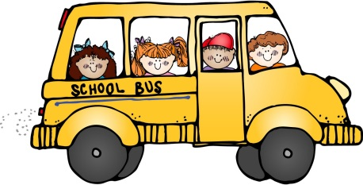**First Grade Supply List**

School Year: 2024-25

☺ Please bring the following school supplies to our Meet and Greet. ☺

Please keep backpacks, water bottles and lunchboxes until the first day of school.

* Backpack (NO BACKPACKS W/WHEELS)
* Lunchbox (if your child will be bringing his/her lunch)
* Water bottle
* 4 separate packs of 24 count Crayola crayons
* Scissors (child size)
* 4 large glue sticks (not the small glue sticks, please)
* 1 pack #2 YELLOW pencil (PRE-SHARPENED, PLEASE)
* Pencil box (must be large enough to easily hold crayons, scissors, and glue sticks but no extra-large boxes, no metal boxes and no pouches, please)
* 3 two-pocket folders (no prongs, different colors) {PLASTIC FOLDERS ONLY, PLEASE} **
* 1 two-pocket folder (with prongs) {PLASTIC FOLDERS ONLY, PLEASE} **
* 3 composition notebooks (100 pages each, WIDE-RULED, no spirals, different colors, no glitter)
* 1 clear pencil pouch with 3 rings (must fit into a 3-ring binder)
* 1 large container of Clorox disinfecting wipes
* 1 container hand sanitizer
* 1 large box of Kleenex
* 1 box of sandwich size baggies (GIRLS ONLY)
* 1 box of gallon size baggies (BOYS ONLY)
* Please make sure your child has supplies such as pencils, crayons, scissors, and glue for home use.

**For folders and composition notebooks, please write your child’s name on the inside cover only, not on the front. Make sure the folders purchased are all different colors. Composition notebooks need to be different colors/designs as well.

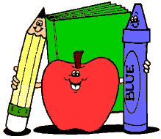

~Your child’s name also needs to be written on the following: backpacks, lunchboxes, scissors, and pencil boxes. The rest of the supplies do not need names written on them.

*Teachers will reassess classroom supplies after the first half of the school year. We will reach out if extra supplies are needed. ☺