SICILIA

**HOTELS**

*Early Arrivals (April 2)*

APRIL 4-9 (5 NIGHTS)

ASMUNDO DI GISIRA  
Via Gisira, 40  
Catania  
+39 095 097 8894  
<https://www.asmundodigisira.com/>

*9 Double Rooms*

*2 Single Rooms*

APRIL 9-12 (3 NIGHTS)

EREMO DELLA GIUBILIANA

Cda Giubiliana

+39 0932 669119

<https://www.eremodellagiubiliana.it>

APRIL 12-14 (2 NIGHTS)

DONNA CARMELA

Contrada Grotte, 5

Carruba di Riposto

+39 095 809383‬

<https://www.donnacarmela.com>

*Breakfast at the hotels is included*

**THE DAY-BY-DAY IN BRIEF**

**THURSDAY APRIL 4**

*ARRIVE CATANIA’S AIRPORT AND TAXI TO HOTEL*

HOTEL CHECK-IN

ASMUNDO DI GISIRA

DINNER WITH DRINKS INCLUDED

VUCIATA KITCHEN MARKET

Via Gisira, 8

+39 095 378 8169

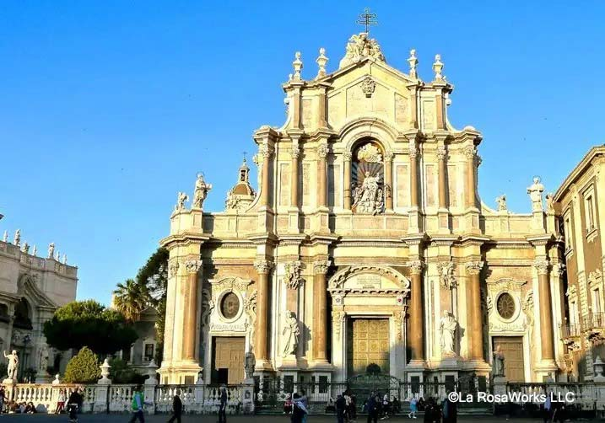

**FRIDAY APRIL 5**

*CATANIA*

*HALF DAY GUIDED TOUR*

9:00 Enjoy a visit to the famous Pescheria Market and a walking tour of Catania with a guide.

You’ll have a special visit with an historic and traditional puppet workshop and meet the puppeteers.

A light street food lunch with arancini is included

Free time in the afternoon

8:00 Enjoy a wine paired dinner in an upscale restaurant with sommelier Mariella

Mariella Ferrara  
+39 331 7892235

Visit the Ancient Greek Theater and other historic spots.

You’ll go to Castelmola, the old fortress town for an almond wine tasting, an area specialty.

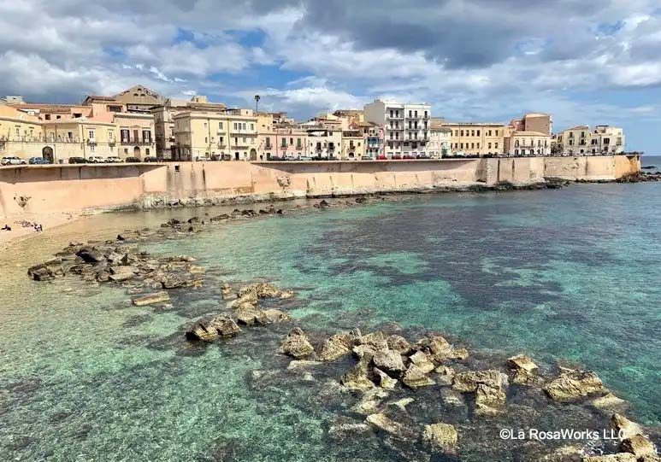

**SATURDAY APRIL 6**

*ORTIGIA*

*HALF DAY GUIDED TOUR*

Meet your guide at the Archeological Park for a walking tour of the ruins and then on to Ortigia, Siracusa’s historical center, to visit the Duomo and other sites.

*(Entrance fees included)*

For a light lunch, you will visit the grand Palazzo Borgia

You’ll hear the story of the owners and get a magnificent view of the piazza.

In the evening Bob will cook a wonderful meal in the kitchen of Asmundo di Gisira

*Eat indoors or out weather depending.*

The market is nearby for shopping. Servers will be on hand to help. Wine is included.

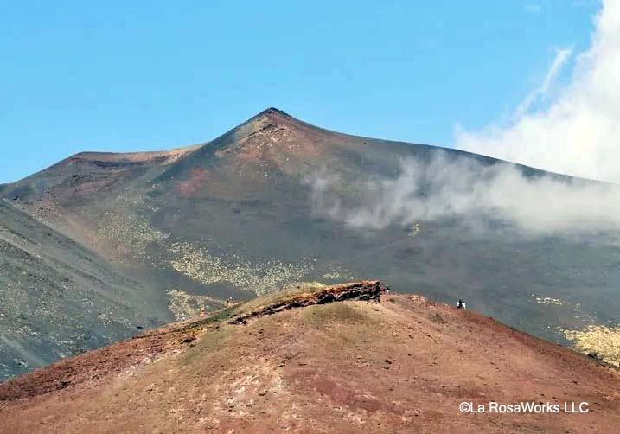

**SUNDAY APRIL 7**

*MOUNT ETNA*

*FULL DAY GUIDED TOUR*

9:00 Drive to the volcanic lunar landscape and enjoy an up-close look at Her Majesty Mount Etna. You will see the extinct craters and learn about the fertility she provides.

On a walk up to the rims your guide will explain the history, geology, mythology and more.

For a tour, tasting and included lunch you will visit an organic winery with a philosophy. You will taste the wines that Etna enables them

to produce.

*(Please wear sneakers and bring a light jacket or sweater)*

Dinner is on your own.

*(Restaurants listed at the end)*

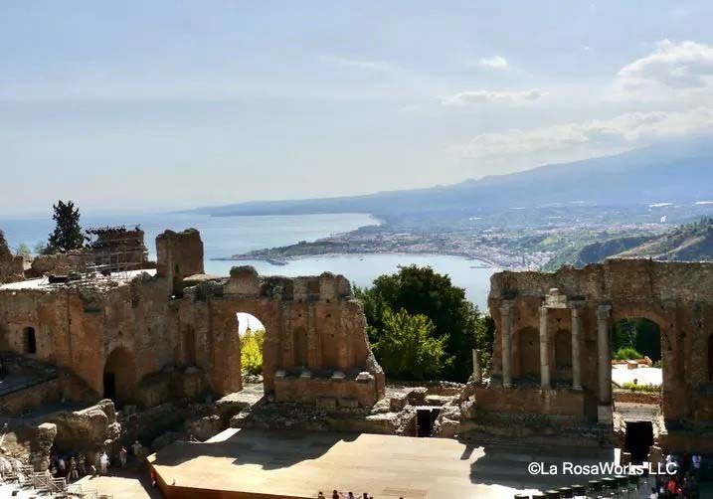

**MONDAY APRIL 8**

*TAORMINA*

*FULL DAY GUIDE*

Enjoy a day trip to Taormina

Your guide will take you to the stunning Greek Theater and a few other important sites.

Enjoy an afternoon to shop and explore.

Don’t miss the beautiful English Gardens.

In the evening Bob will again cook in the kitchen of Asmundo di Gisira

The market is nearby for shopping. Servers will be on hand to help. Wine is included.

Dessert will include typical sweets from Catania.

**TUESDAY APRIL 9**

*PIAZZA ARMERINA - RAGUSA*

*HALF DAY GUIDED TOUR*

HOTEL CHECK – OUT

Enroute to Ragusa stop in Piazza Armerina for a guided visit to the Villa Romana del Casale, a 4th century hunting villa with world class mosaics. UNESCO world heritage site.

*(Entrance fees and whispers included)*

Light lunch is included at the top trattoria in town, Casa Garibaldi

HOTEL CHECK – IN

EREMO DELLA GIUBILIANA

Wine Tasting and light dinner at the hotel in the evening.

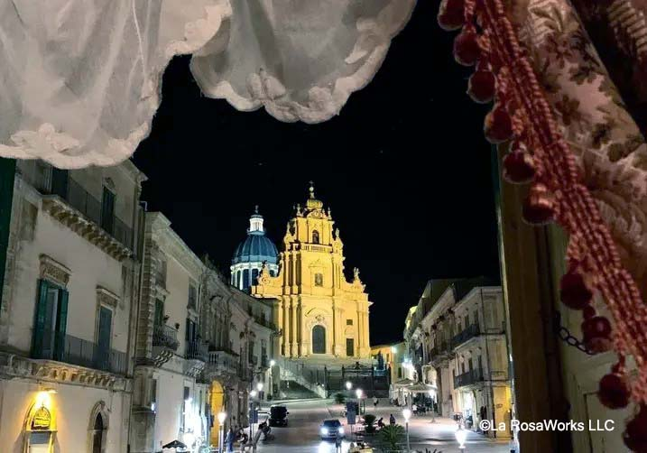

**WEDNESDAY APRIL 10**

*RAGUSA*

*FULL DAY GUIDED TOUR*

You’ll enjoy a morning tour of the Baroque hill town of Ragusa with a visit to Cinabro Bros, among the last workshops of the traditional Sicilian cart.

Visit La Timpa, an historic wheat and oil mill for an olive oil experience, ricotta cheese demonstration & included lunch.

*(Entrance fees included)*

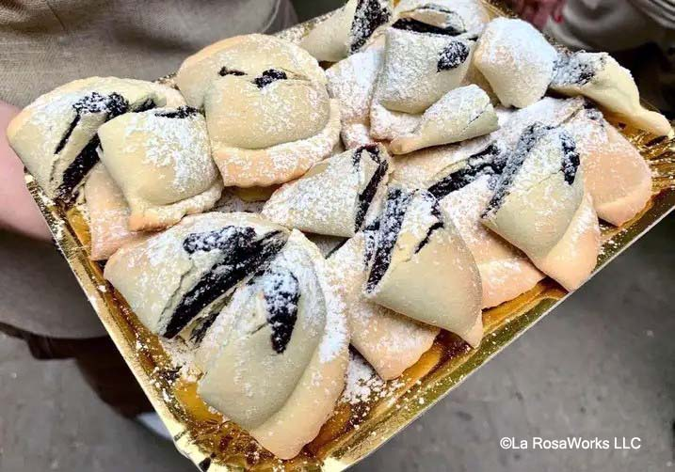

**THURSDAY APRIL 11**

*MODICA*

*FULL DAY GUIDE*

Modica is Sicily’s chocolate capital.

Visit a chocolate laboratory and enjoy a tour, tasting and light lunch included. You’ll learn about the chocolate-making process from bean to bar and create your own!

Dinner in Ragusa at the Michelin awarded

Locanda Don Serafino

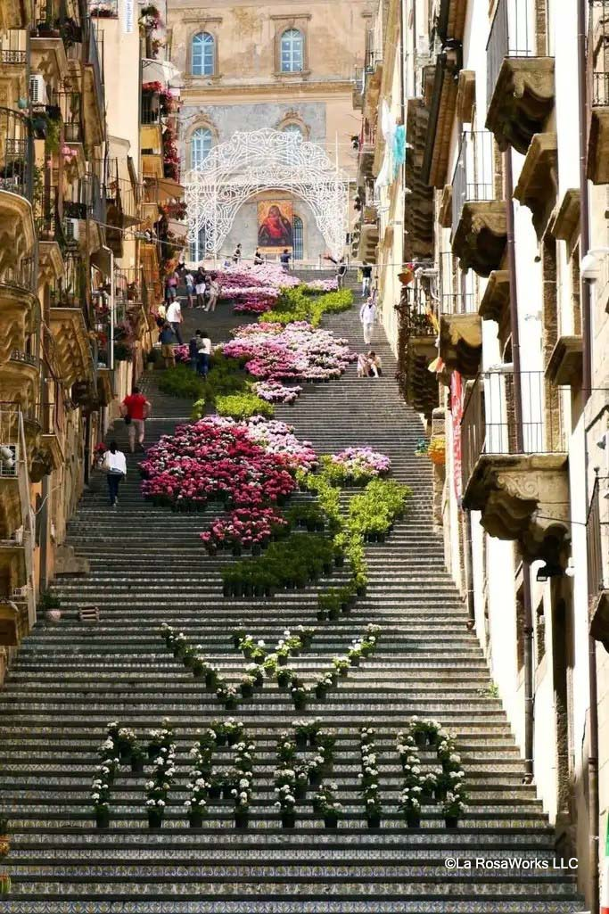

**FRIDAY APRIL 12**

*CALTAGIRONE*

*HALF DAY GUIDED TOUR*

HOTEL CHECK – OUT

Sicily’s important ceramics production center resembles an open-air museum, with an impressive central staircase. Meet your guide at the Navanzino Brothers Ceramics workshop, to learn all about the history and process from this very important family.

*(Entrance fees included)*

For a light lunch you will visit a nearby winery, producing wines of the area with their own approach.

The cantina itself is full of interesting and historic machines.

Continue to the Etna area.

HOTEL CHECK-IN

DONNA CARMELA

A proper country dinner will be at the home of your guide where they will cook local recipes for you and offer wine and homemade liqueur to taste, with entertainment included.

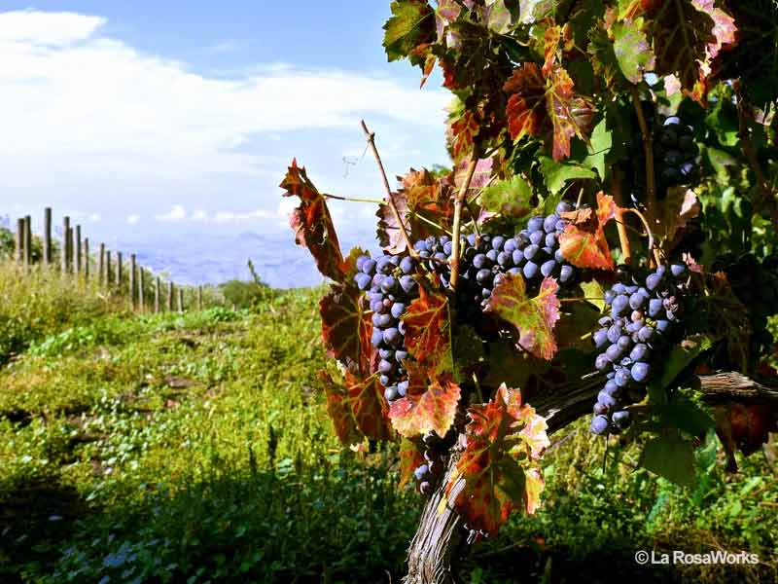

**SATURDAY APRIL 13**

*ETNA’S WINE ROAD*

Meet your guide to take a day trip to Etna’s north wine road for another winery visit and included lunch at Pietradolce, and then on to the medieval town of Randazzo for a gelato tasting from a master gelato maker.

Dinner will be at the hotel’s wonderful restaurant, wine included.

**SUNDAY APRIL 14**

*DEPARTURE AND PRIVATE TRANSFER TO CATANIA’S AIRPORT*

***INCLUDED IN THE COST***

Accommodations as per itinerary and City Tax to the hotels

All breakfasts

Lunches, dinners, and tastings as noted

Transportation in air-conditioned comfortable cars/vans

Expert guides as noted

Admission fees when

accompanied by guides

Gratuities for guides and drivers

Restaurant recommendations for when you are on your own

Travel information

Emergency contact in Sicily

***CANCELLATION POLICIES***Tour deposits are refundable up to 120 days prior to departure date. Deposits made after 120 days are non-refundable.  
Final payment invoices will be sent to you at least 60 days in advance of departure. The tour cost and services are non-refundable at that point.

**Not Included:**

**Gratuities: See below**

**Hotel city tax must be paid by the individual. It varies by location and averages around E3 per person.**

**Travel Insurance is highly recommended.**

**Compare policies here:**

<https://travelinsurancemaster.com/>

***SOME FINE PRINT***

The boutique nature of this itinerary means that it is subject to minor changes, updates and even additions as we get closer. Any changes would reflect the goal of enhancing your Sicilian experience.

**…………………………………………………**

**EMERGENCIES: For tour related emergencies, kindly reach out to my office colleagues on WhatsApp**

**in Palermo, in your time zone:**

**MARIALUISA FIORITO**

**+39 327 6190641‬**

***Please see the note about communicating via WhatsApp***

***…………………………………………………***

***Please reach out to your individual guide for the day or drivers directly should you need to communicate with them.***

**WHATSAPP** is an App for the phone that most Sicilians use to communicate with foreigners. Please upload it to your phone for free and easy communication with others including friends and family at home who also have it installed.

***A NOTE ABOUT WALKING***

Any visit to Sicily will include walking on inclines, climbing some steps, and encountering uneven surfaces, especially in agricultural settings.

Comfortable, sturdy shoes are highly recommended.

Carrying a lightweight, foldable walking stick is a good idea if you require support (Inexpensive online).

***TRAVEL CHECK-LIST***

**Double check that your passport is valid to 6 months after your departure from Sicily**

**NEW ‘VISA’ REQUIREMENT**

**Beginning in 2024, everyone going to Europe must fill out a simple online form and be approved for travel. There is a small fee.**

<https://etias.com/etias-requirements/etias-for-american-citizens>

Notify your bank of your travel dates

Notify your credit card company

Purchase a cell phone day pass plan

Remove unnecessary items from your wallet

Leave a copy of your itinerary with a family member or friend

Make sure your luggage is labeled and identifiable. Luggage can look very similar.

Carry a copy of your passport in a different place from your actual passport

Check 3BMeteo weather app to help you pack

***SUGGESTED ITEMS TO PACK***

Sneakers/comfortable

walking shoes

Sunscreen

Hat

Portable Walking Stick

Refillable filtered water bottle

(See note below)

Tissues, ladies…

A light sweater and light umbrella are always recommended

Dress in Sicily is generally casual, smart casual for dinners.

***Leave room*** *to bring things home with you such as packaged cheese, wine, honey, olive oil, ceramics*…

The most common lament I hear is

***“I wish I had more room!”***

***WEATHER***

Check the extended forecast to help you pack and while in Sicily, I recommend the App **3B Meteo** for good weather information

***MONEY***

ATM machines are easily found in the bigger towns. In the smaller towns, please ask.

Credit cards are widely accepted in restaurants and shops but less so in small bodegas and trattoria.

***American Express and Diners Cards are sometimes not welcomed. Please have an alternate card with you.***

You may want to let your bank and credit card company know that you will be traveling

***TIPPING***

Tips are discretionary and appreciated. These are suggestions.

RESTAURANTS

If no ‘coperto’ is added to your check, 10% is appropriate for good service. If it is already included, you can leave a few extra Euro

as you wish.

HOUSEKEEPING

E2 – E3 per night is typical

**CELL PHONE SERVICE** is more reliable now than ever but, in the hills and small villages, with thick walls in historic buildings, it can be spotty. I carry a global hotspot

***WATER***

The water in Sicily is not unsafe but owing to old pipes, the culture is bottled water. **Use a Brita refillable water bottle with a filter** so I can get water from the tap and not contribute to the landfills. They are available online and not expensive.

***ELECTRICITY***

Plug adapters labeled Southern Europe are what you will need. I suggest a small power outlet with room for a couple of plugs and USB ports since hotel rooms don’t always have many outlets. The hotels have hair dryers.

***SUGGESTED READING***

***Seeking Sicily***

John Keahey

A wonderful read and good overview of Sicily including history, mythology, and a travel writer’s view of the people and their traditions**.**

***The Peoples of Sicily***

Louis Mendola

A very readable history to explain the cultures, dominations, and layers.

***The Leopard***

Giuseppe Tomasi di Lampedusa

A classic piece of literature that considers the Risogimento of the late 19th century. Love, politics, ageing and Sicily all wrapped into one magnificent read.

***The Wine Dark Sea***

Leonardo Sciascia

Short stories written by one of Sicily’s most important authors and political activists of the 20th century.

***The Florio’s***

Stefania Auci

An historical fiction that depicts the life of this very important Sicilian family beginning in the 18th c. A fascinating read of the developing merchant class of that period.

***Mattanza***

Theresa Maggio

Theresa’s second book about Sicily after *The Stone Boudoir*, this one describes the Arab tradition of tuna fishing that lasted up until recent times. Her discovery, her love affair and her insights make it a wonderful read whether tuna fishing interests you or not.

***Bitter Almonds:***

***Recollections & Recipes from a Sicilian Girlhood***

*Maria Grammatico*

This light read will tell you about the life of a girl raised by the nuns when her family couldn’t afford her, and what she learned that has served her well even today.

[Untold Italy Podcast](https://untolditaly.com/palermo-not-what-you-expect/) about Palermo with Karen La Rosa

Untold Italy Podcast [about Noto](https://untolditaly.com/exploring-sicilys-val-di-noto/) with Karen La Rosa

***MUST TRY FOODS IN SICILY***

Almonds - anything made with almonds

Arancini – stuffed fried rice balls

Cannoli made with sheep’s milk ricotta

Casatelle – sweets with ricotta cream

Cassata cake – made with ricotta cream, marzipan and more!

Citrus – lemon and oranges

Gelato or Granita with Brioche

Fish, fish, fish, fish

Marzipan – and cookies made with

almond paste

Pasta alla Norma (a classic)

Pasta – Busiate with

Pesto alla Trapanese

Pasta – Nero di Seppia (squid ink)

Pistachios – anything made with pistachios

Pizza – it’s delicious

Sarde a Beccafico

Sicilian wines from various areas.

Street food in Palermo

Torrone – almond nougat

Untold Italy Podcast about [Food in Sicily](https://untolditaly.com/episode-107-tastes-of-sicily/) with Karen La Rosa

***SICILIAN GOODIES***

Clients always ask for a local resource for quality Sicilian foods like they enjoyed on their trip. I highly recommend Nancy Alessi’s selection at [A Terra](https://www.aterra.co/)

She is professional, packages beautifully, and she gets it. I order from Nancy often.

<https://www.aterra.co/>

***SICILY – JUST THE FACTS***

Sicily is the largest island in the Mediterranean with a 600-mile coastline and 9,925 sq. miles of land. Its location made it of great strategic importance to more than a dozen conquering peoples. The resulting fusion of their diverse cultures, traditions, histories, and languages gives us richness and beauty that is hard to match anywhere else. It is the original melting pot.

The population is just over five million Inhabitants. Palermo is the capital. There are 9 Provinces: Trapani, Palermo, Messina, Catania, Enna, Ragusa, Siracusa, Caltanissetta, and Agrigento

The highest point in Sicily is Mount Etna at 10,902 ft. (3350 meters). It is still active. Etna is situated in a large national park and apart from ash, rarely causes problems.

***SICILY’S FLAG***

The Sicilian flag dates to 1282, after the Sicilian Vespers of Palermo, when on Easter eve the Sicilians revolted successfully against the rule of Angevin Charles I. The rebellion was fierce and ushered in 500 years of Spanish rule. The flag is bisected diagonally into red and yellow. The red represents the municipality of Palermo, the yellow represents that of Corleone, an important agricultural city during medieval times and together with Palermo, behind the insurrection that eventually spread all

over the Island.

The flag also includes a central Trinacria, carrying all its symbolism for Sicily and representing the infinite cycle of time. Things come to those who wait.

***SICILY’S TRINACRIA***

**THE TRINACRIA** (Triskelion, Triskeles) is Sicily’s historic symbol. It has 3 legs for the 3 promontories of the island, with the head of Medusa in the center. Often with wings, symbolizing the passage of time, with snakes, symbolizing wisdom, and wheat from the time when Sicily was a granary to Rome, you will see many variations all over Sicily, including the pleasant smiling faces of today. Greek Mythology runs through much of Sicily’s history, with images of Demeter and Persephone and talk about Ulysses and the Cyclops often mentioned.

***SICILY’S HISTORICAL***

***TIMELINE IN BRIEF***

Pre-Historic: 20,000 – 750 BC

Phoenicians: 900 – 700 BC

Greeks: 750 – 215 BC

Romans: 264 BC – 468 AD

Goths & Byzantines: 468 – 827

Arabs: 827 – 1061

Normans: 1060 – 1194

French Angevins: 1266 -1282

Swabians (Hohenstaufen):

1198 - 1254

Spanish: 1282 – 1806

The East’s great Earthquake: 1693

Italy’s Unification: 1861

WWII Allied Troops in Sicily: 1943

The West’s great earthquake: 1968

***THE SICILIAN LANGUAGE***

Sicily’s history is as layered and complex as the story of its language. Sicilian is not a dialect, it is a language that came not only out of Latin, but from influences of the early populations. The Sicani came from Iberia, the Elymians from Libya, the Siculi from the mainland. The Phoenicians hailed from Lebanon and Punic was spoken by the Carthaginians. Greek added another layer, and it was only from the Romans that Latin came to Sicily.

Evolving over time to include words of Arabic and French origin, under Frederick II there was a recognized School of Poetry written in the Sicilian vernacular.

There are regional dialects of Sicilian that vary based on the heavier influences of certain populations, for example, Arabs in the west and Greeks in the east.

An oral tradition, this language is only now being taught as an elective in school so that it is preserved. All students in Sicily are taught the Florentine Italian that was adopted after unification in 1861.

Dda farfalle accussi vaga

Lu muggitu di li tori

L’innuccenza chi v’appaga

Tutti parranu a lu cori

*The light and filmy butterfly*

*The cattle’s low sighing*

*Their innocence will satisfy*

*The heart with hunger crying*

Giovanni Meli

1740-1815

**DISCLAIMER**

La RosaWorks acts only as an agent for the various independent suppliers that provide accommodations, transportation, sightseeing, activities, or other services connected with this tour. Such services are subject to the terms and conditions of those suppliers.

La RosaWorks accepts no liability whatsoever for any injury, damage, loss, accident, delay, or any other incident which may be caused by the negligence, defect, default of any company or person performing these services.

La Rosa Works does not accept responsibility for losses, injury, damages, or expenses of any kind due to sickness, weather, labor strikes, hostilities, wars, terrorist acts, acts of nature, local laws, or other such causes. All services and accommodations are subject to Italian laws and regulations.

La RosaWorks is not responsible for any baggage or personal effects of any individual participating in the tours/trips it arranges. Individual

travelers are responsible for purchasing a travel insurance policy that will cover some of the expenses associated with the loss of luggage or personal effects.

**“All of Sicily is a dimension of the imagination.”**

Leonardo Sciascia

***Thank you for traveling***

***with us!***

**Karen La Rosa**

**La RosaWorks Sicily Tours**

**& Travel**

[**https://www.larosaworks.com/index.php**](https://www.larosaworks.com/index.php)

**917-225-8415**

[**kjlarosa@larosaworks.com**](mailto:kjlarosa@larosaworks.com)

***Please send a photo or two!***

**RESTAURANTS IN CATANIA**

**BOHÈME MIXOLOGY** BAR Via Montesano, 27/29, | +39 095 250 3340

A quirky Speakeasy style bar with used furniture and a cute signature pug dog. They have signature cocktails and will make one based on your tastes using natural herbs and spices. Near Piazza Stesicoro.

**CONCEZIONE** Via G. Verdi 143,  | +39 095 16936122 This newcomer already has Michelin recognition. Tasting menus are refined but rooted in the traditions and memories of this young native of Catania.

**OSTIER VINOTECA** Via Vittorio Emanuele, 81 | +39 095 715 9247

Terrific food. Locally sourced ingredients. Great wine selection: Opens at 6:00 for those who like to dine on the early side. Closed Mondays and open for lunch only on Sundays.

**VUCIATA KITCHEN MARKET** Via Gisira, 8 | +39 095 378 8169

Opened in 2019, everything here is fresh, seasonal, and Slow Food in nature. Best mussels! Located in the fish market, open for lunch and dinner.

**MeCUMPARI TURIDDU** Piazza Turi Ferro 36-37-38 | +39 095 715 0142

This Slow Food restaurant is more expensive than the average, but worth it. The menu is full of regional specialties and the sources for the ingredients are identified. The chef is wonderful and takes this food to another level.

**TANTIKKIA** Via Gisira, 28 | +39 095 716 8188

A favorite of my sommelier friend this place has nice food and is not fussy

**Km.0** Via Antonino Longo 26/28, | +39 347 732 7788. Small and simple, dedicated–as the name suggests–to local products. There is a strong focus on seasonality and quality of their raw materials. The menu changes according to the season.

**PUTI** Via Sant'Euplio, 108, | +39 346 8002859. An outstanding restaurant really close to the Liberty Hotel.  Recommended by a client.

**SAVIA** Via Etnea, 300/302/304 | Via Umberto, 2/4/6 |+39 095 322335

Don’t think of buying arancini or cannolo anywhere else – these are the best in town! This old-style café serves amazing ice creams, granita, and pastries too. Lunch only.

**RAZMATAZ WINE BAR** Via Montesano, 17 | +39 095 311 893

Great cheese and wine; funky and crowded for a reason. Good wine list and beer, tight in the heart of nightlife.

**VINICOLO GLAM & DRINK** - Via del Colosseo, 8 | +39 095 836 0730

This is a nice place for great pizzas and pastas with a great wine list. Across from Piazza Stesicoro’s Roman ruins, it is reasonable and very pleasant.

**SAPIO L’ESTETICA DEL GUSTO** – Piazza Gandolfo Antonio 11 | +39 350 1947542‬

Exquisite dining from a young Michelin star chef and his front of house partner. Excellent wine list. Located on the edge of the city but it’s worth a taxi ride, it’s a special treat and one of the top meals I’ve had anywhere. Closed Mondays, Tuesdays. dinner only.

**IL SALE ARTE CAFÉ** Via Santa Filomena, 10/12 | +39 095 316 888

Hip, modern, pizzeria, with other delicious food at reasonable prices. Andrea Graziano selects the best

Sicilian products.

**MATERIA spazio cucina** Habitat Hotel, Via Teatro Massimo, 29 | +39 0958266755

An experience where colors, flavors, territory and working hands have found a meeting point halfway

between the art of hospitality and the concept of dining.

**OSTERIA ACQUALAVICA** via Cardinale Dusmet 35 | +39 095 751 5017 The dishes here are traditional and comforting, including an excellent caponata antipasto, “fuori della Norma” pasta, fried fish and fish carpaccio, as well as other seafood options among the main courses.

**TRATTORIA U FUCULARU**  Via Euplio Reina, 20 | +39 348 567 8821. A family-run trattoria that aims to bring tasty dishes to the tables of its guests. The Sicilian cuisine of this restaurant will captivate you from the first moment, making you explore all the richness and freshness that Sicily is able to offer.

**TRATTORIA CASALINGA DA NINO MANNINO** Via Biondi, 19 I +39 095 311319.  Typical Sicilian cuisine, close to Romano House Hotel.

**WINE & CHARME** Via Vittorio Emanuele, 139 | +39 095 321 773 Fabulous enoteca and specialty food shop; great place to buy products to take home - they ship, too.

**IL CALICE DEI GRULLI (The Cup of Grulli)-** Via A. di Sangiuliano  | +39 339 8862345. Offers a wide choice of Sicilian and national wines focusing on native wines and emerging companies. Our cutting boards offer a variety of both Sicilian and Tuscan products.

**CICCHETTERIA GLERA** - Via Museo Biscari 19 | +39 349 848 3547.  Very nice wine bar by  the Palazzo Biscari.  Has outdoor seating.

**MEZZAPAROLA  -** Via Landolina, 23 | +39  333 691 3266. Mezzaparola" is a Sicilian way of saying used during a dialogue between several people which means: "no need to add other words, I already understood what you mean so a half word was enough for me to understand you!"  From the moment you walk in, you're greeted with an intimate and cozy atmosphere that sets the perfect mood for a night out with friends or a date.