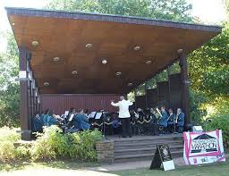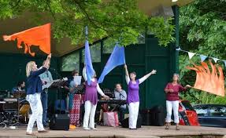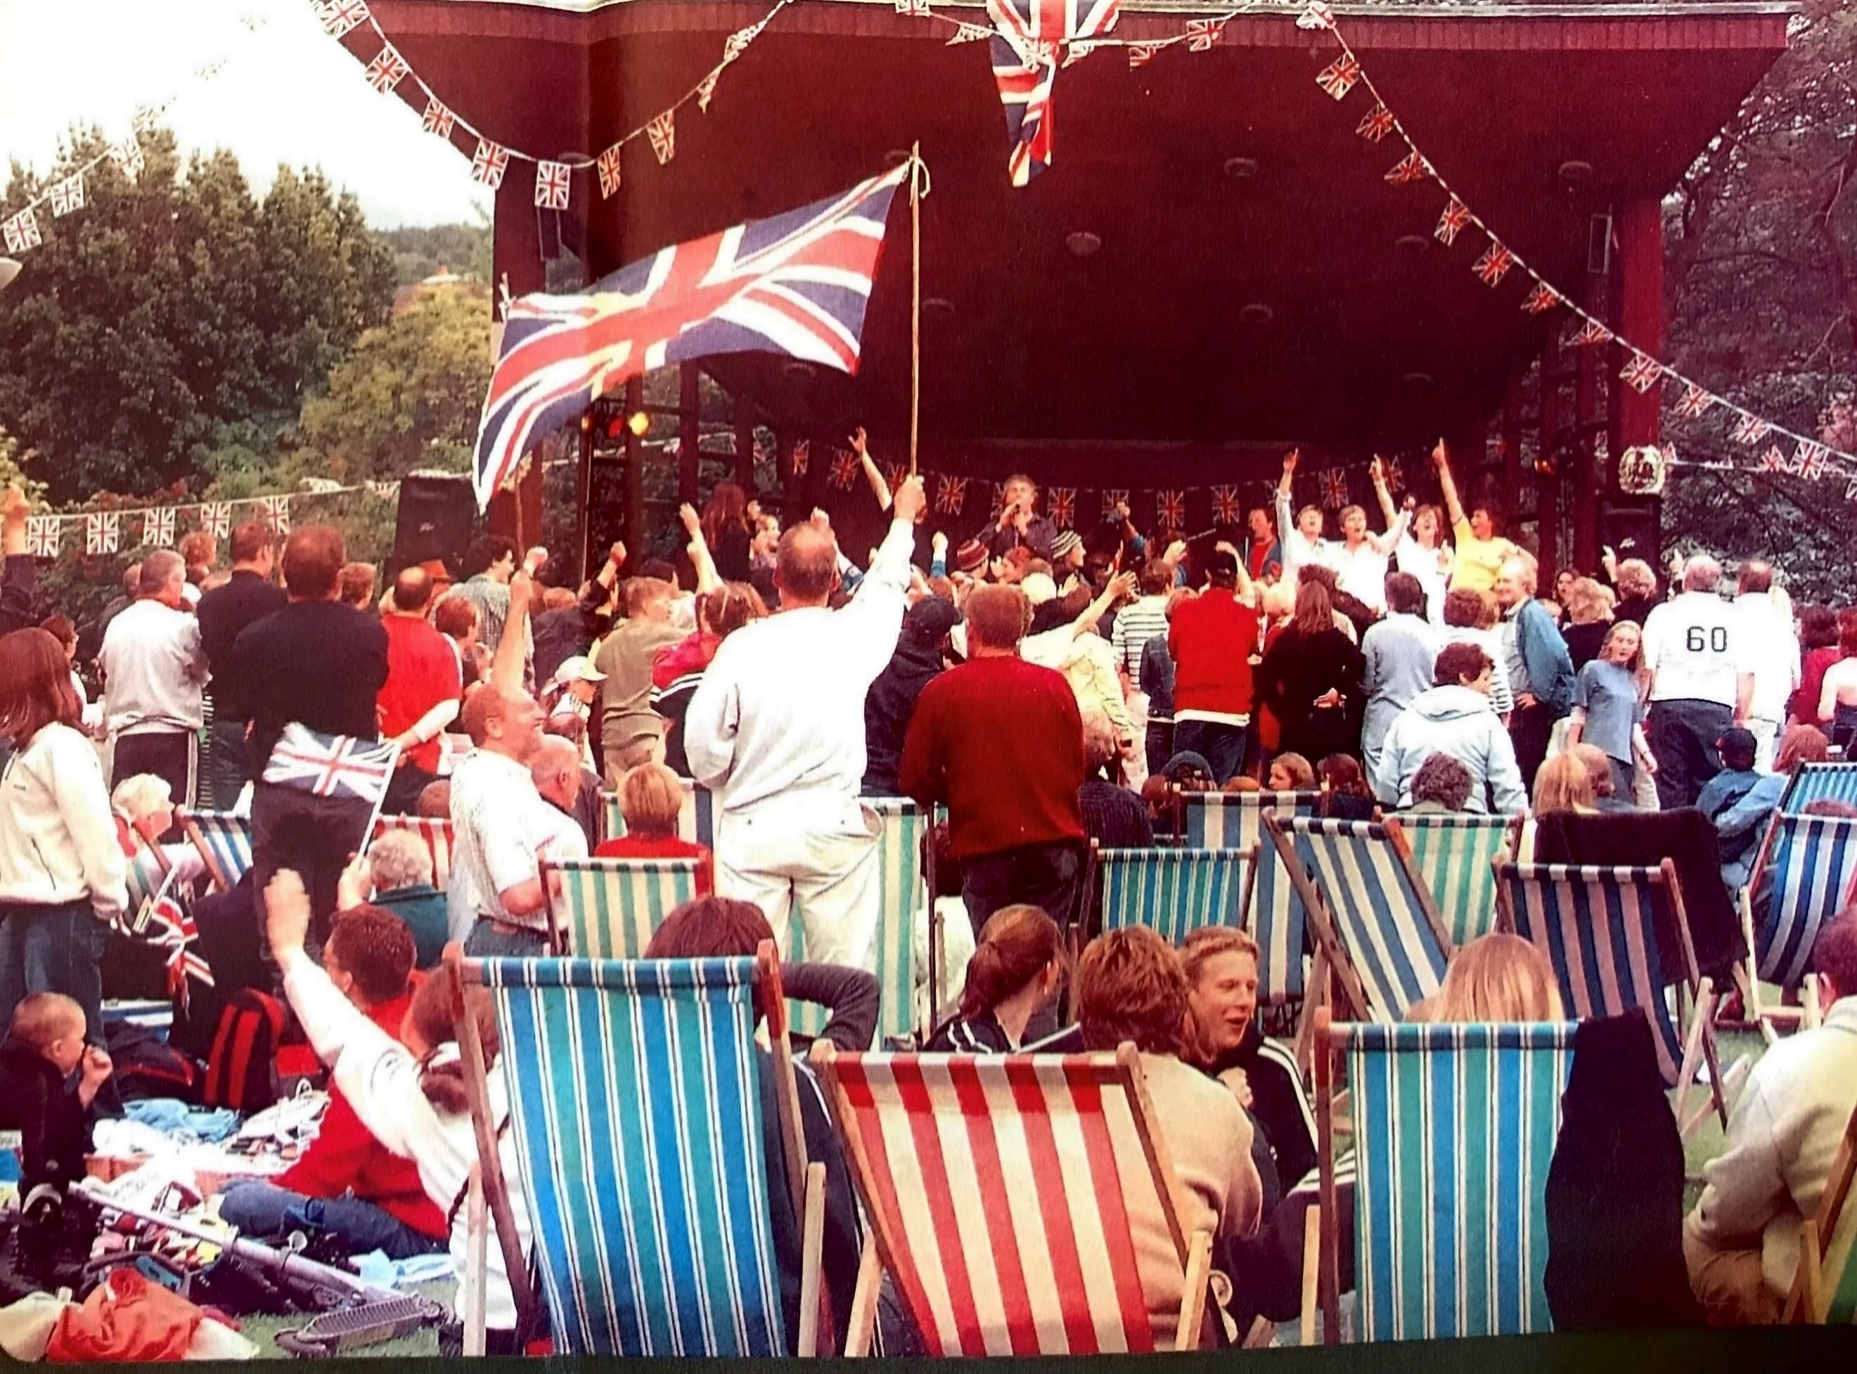
JUNE  Sun 4th - TBA  Sat 10th – Slowhand Jules  Sun 11th – Wivey Wind Band  Sat 17th - Crosstown  Sun 18th – Andy Doran  Sat 24th - Evolution  Sun 25th – Wellington Silver Band | JULY  Sat 1st - DVO  Sun 2nd – Burtle Silver Band  Sat 8th - Bossa Beleza  Sun 9th – West Somerset Brass Band  Sat 15th – Wiveliscombe Town Band  Sun 16th – Minehead Community Orchestra  Sat 22nd - Minehead Male Voice Choir  Sun 23rd – The Kingstons  Sat 29th – The Understairs  Sun 30th – King Alfred Concert Band
AUGUST  Sat 5th – The Mighty Rough Justice  Sun 6th – Weston Brass Band  Sat 12th – Beverly Brothers  Sun 13th – The Fun Puppets  Sat 19th – Jessie and the Skunknecks  Sun 20th - Foxwillow  Sat 26th – Hugill’s Crew  Sun 27th - Samphire | SEPTEMBER  Sat 2nd - Silverback  Sun 3rd – Taunton Concert Band  Sat 9th - TBA  Sun 10th – Kingsbury Episcopi Band  Sat 16th - TBA  Sun 17th - TBA

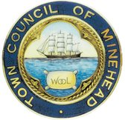
Free entry and all performances start at 2.00 pm.

Sponsored by Minehead Town Council

