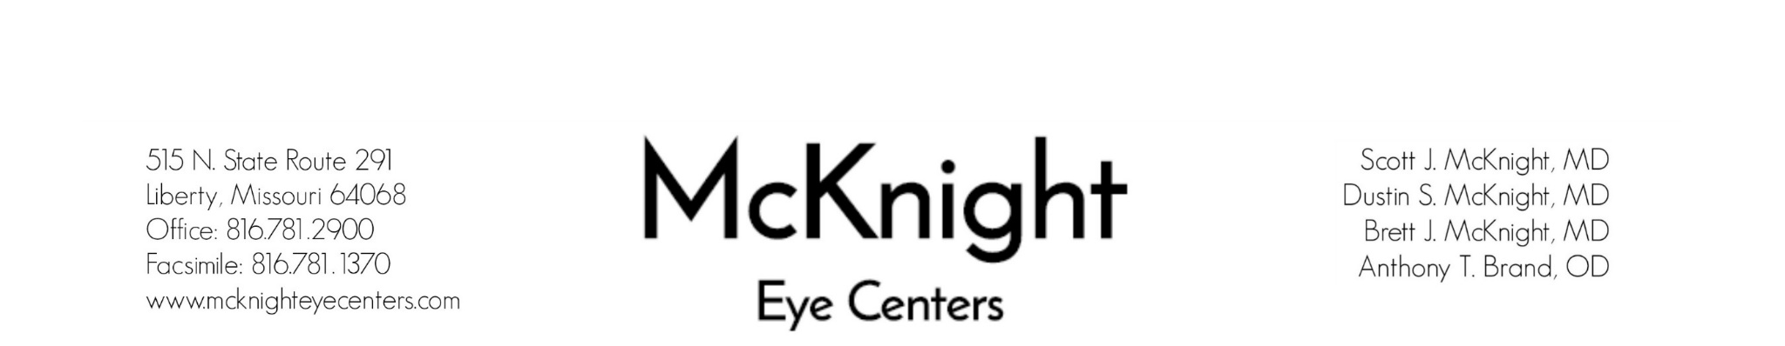

Agreement of Financial Responsibility

I, _________________________ acknowledge that McKnight Eye Centers will submit today’s annual exam to my insurance company on file for payment and that I am fully responsible for any charges that may not be covered under my insurance benefits. I understand that my insurance company may not cover the charge of refraction that will be done during today’s exam, and I am responsible for the $25.00 charge incurred for that service.

_______________________________
Signature of Responsible Party

_______________________________
Date

