Sesamoid Disorders of the First Metatarsophalangeal Joint
Allan Boike, _{DPM}^{e}, Molly Schnirring-Judge, _{DPM}^{a,b,c,d,}*,
Sean McMillin, DPM^{f}
KEYWORDS
Sesamoids Feet First metatarsophalangeal joint Disorders
The sesamoids of the feet were named by Galen circa 180 CE because of their resemblance to sesame seeds. These tiny bones were believed by the ancient Hebrews to be indestructible and therefore the housing for the soul after death, which would ultimately be resurrected on the Day of Judgment.¹ However, the sesamoid complex, which transmits 50% of body weight and more than 300% during push-off, is not
invincible and is susceptible to numerous pathologies.^{2,3} These pathologies include sesamoiditis, stress fracture, avascular necrosis, osteochondral fractures, and chondromalacia, and are secondary to these large weight-bearing loads. This article discusses sesamoid conditions and their relationship with hallux limitus, and reviews the conditions that predispose the first metatarsophalangeal joint (MPJ) to osteoarthritic changes.
There is much debate regarding the causes of hallux limitus and rigidus and the role of the sesamoids in precipitating the decreased range of motion of the first MPJ has been considered in some detail. Typically, little is done to the sesamoids at the time of surgical treatment of the hallux limitus deformity. This article reviews the recent

- Cleveland Clinic Foundation- Kaiser Permanente Podiatric Surgical Residency Program, 10 Severence Circle, Cleveland Heights, OH 44070, USA
- Ohio University, Firelands Regional Medical Center, Residency Training Program, 111 Hayes Avenue, Sandusky, OH 44870, USA
- Graduate Medical Education, Mercy Health Partners, Toledo, OH, USA
- Private Practice, North West Ohio Foot and Ankle Institute, LLC, 530 Washington Street, Port Clinton, OH 43452, USA
- Foot and Ankle Center, Orthopaedic and Rheumatologic Institute, Cleveland Clinic, Cleveland, Ohio
- Cleveland Clinic/Kaiser Permanente, Department of Orthopaedics Podiatric Residency Training Program, Cleveland, Ohio
* Corresponding author. Cleveland Clinic Foundation- Kaiser Permanente Podiatric Surgical Residency Program, 10 Severence Circle, Cleveland Heights, OH 44070.
E-mail address: mjudgemolly@aim.com
Clin Podiatr Med Surg 28 (2011) 269–285
doi:10.1016/j.cpm.2011.03.006 podiatric.theclinics.com
0891-8422/11/$ – see front matter 2011 Elsevier Inc. All rights reserved.
literature of sesamoid disorders and, more specifically, their role in hallux limitus. Potential treatment options are also discussed.

ANATOMY
The sesamoids are located centrally and plantar to the first metatarsal head where they are imbedded within the plantar plate. There are 3 sesamoids associated with the great toe joint; 2 are considered constant and lie beneath the first metatarsal head, and the third, referred to as inconstant, when present develops inferior to the hallux interphalangeal joint (HIPJ). These bones may be semiovoid, bean shaped, or circular and so are considered variable in morphology. The 2 sesamoids of the first MPJ are not typically equal in size. The tibial sesamoid is larger, ovoid, and elongated, and is encased within the medial head of the flexor hallucis brevis (FHB) tendon. The smaller fibular sesamoid is smaller and more circular and is surrounded by the lateral head of the FHB tendon. The larger size of the tibial sesamoid bears more weight than the fibular sesamoid and is believed to predispose the medial sesamoid to more pathology. Portions of the adductor and abductor hallucis tendons also insert on the sesamoids. The sesamoids are suspended by a medial and lateral sesamoidal ligament that extends from the metatarsal head and inserts on the medial portion of the tibial sesamoid and lateral portion of the fibular sesamoid. This ligamentous stirrup-type arrangement about the sesamoid apparatus contributes to the plantar plate of the first MTPJ; a structure understood to be vital to the gliding function of the joint. An additional ligamentous attachment includes the deep transverse intermetatarsal ligament (DTIL) extending from the fibular sesamoid to the neck of the second metatarsal as well as an intersesamoidal ligament that serves as an attachment between the sesamoids and contributes to the plantar plate.^{1,2,4,5}
The function of the sesamoids is to absorb and disperse weight bearing from the metatarsal head. This function in turn provides protection to the flexor hallucis longus (FHL) tendon.^{4,6} The sesamoids increase the moment arm of the flexors, increasing their power and supplementing the mechanical advantage of 1st MTPJ motion. The sesamoids are invested within the FHB tendons and function to absorb shock and enhance the gliding function of the MTPJ.⁴
Understanding the arterial supply to the sesamoids is important to investigating sesamoid injury, understanding healing and allows for more accurate prognostication regarding surgical outcomes. Each sesamoid has been shown to receive its own individual artery for nutrition, but may have 2 or 3. Blood supply stems from the medial plantar artery (25%), the plantar arch (25%), or from both sources (50%).^{2,4} Both sesamoids receive blood supply from proximal and plantar sources, but are less well vascularized distally. The proximal supply enters through the FHB insertion, and plantarly via midline capsular attachments. The more sparse distal supply comes from the capsule and may help explain some disorders such as osteonecrosis or nonunion of fractures (Fig. 1).^{1,2} Because of the predominately plantar vascular supply, incisional
approaches are safer from the dorsum or medial approach.⁴
Ossification of the sesamoids occurs between the ages of 7 and 10 years, beginning usually with the fibular sesamoid followed by the tibial sesamoid.⁵ Agenesis or congenital absence of the sesamoids is rare. There are typically multiple ossification centers, which may result in bipartite sesamoids caused by incomplete fusion of these 2 centers. The tibial sesamoid is bipartite in approximately 10% of the population (Fig. 2A, B), whereas the fibular sesamoid is rarely bipartite. In patients who have a bipartite tibial sesamoid, 25% have the bilateral condition.^{2,4} Weil and Hill⁷ reported a statistically significant correlation between the incidence of a bipartite tibial
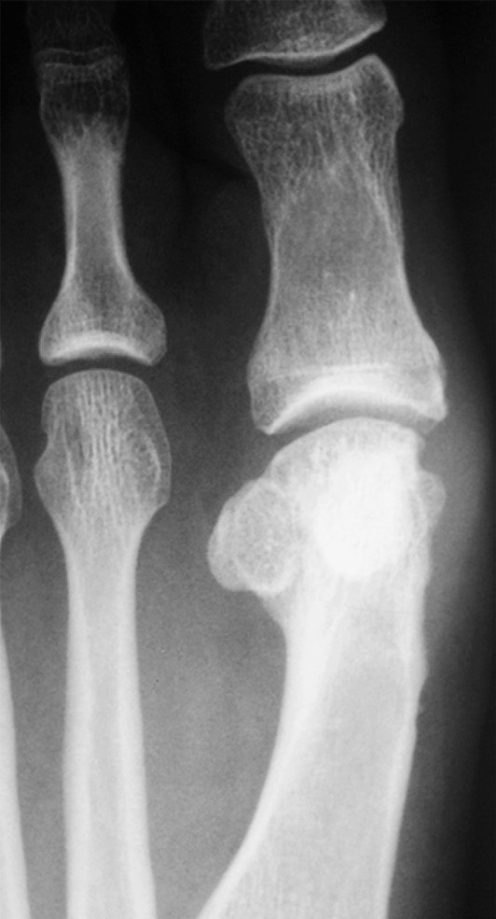
Fig. 1. Avascular necrosis of the tibial sesamoid as a result of an aggressive debridement of the medial eminence to reduce a bunion deformity. Note the sclerotic appearance of the sesamoid bone and the irregular residual medial border of the metatarsal head and neck as evidence of an aggressive eminence resection. The vascular supply to the sesamoids is at risk whenever surgical intervention for reduction of the bunion deformity is pursued.
sesamoid and hallux valgus deformity, hypothesizing that the bipartite tibial sesamoid causes an imbalance in the intrinsic musculature.

CLINICAL FINDINGS
Sesamoid disorders account for 9% of foot and ankle injuries and 1.2% of running injuries.² Although any one can suffer from a sesamoid disorder, chronic sesamoid afflictions seem to occur more frequently in active patient populations. The pain associated with sesamoid disorders is variable and can range from generalized joint pain or capsulitis of the first MPJ to pain localized to the affected sesamoid or the sesamoid apparatus plantarly. The pain may be constant or simply aggravated by weight-bearing activity. A chief complaint of pain around the big toe or the sensation of a snapping about the joint after running can be the harbinger of sesamoid
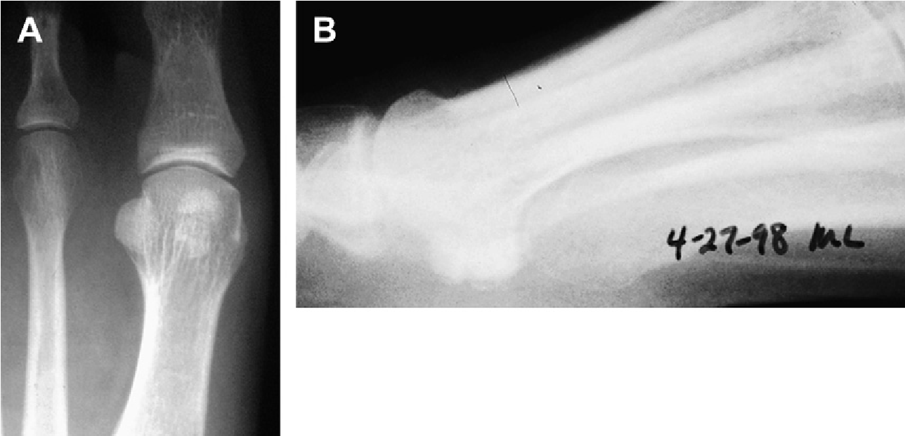
Fig. 2. (A) Bipartite tibial sesamoid on plain film dorsal plantar projection. Associated here with a short first ray segment and functional hallux limitus, it is easy to appreciate that the tibial sesamoid is in 2 pieces with a well-circumscribed erosion within its most proximal lateral pole. The distal pole appears almost crescent in shape. (B) The bifid appearance can be elucidated from this view; however, given the overlap with the fibular sesamoid, the dorsal plantar view remains the optimal projection to assess this morphology.
dysfunction. Generally, pain is expressed during the final stage of stance phase when the hallux is extended. Trauma, a change in activity or an increase in typical activity may
precede an acute fracture or stress fracture. Burning, radiating, or pins-and-needles sensation may indicate neuritis incited by edema, inflammation, or by a displaced fracture.⁵ The differential diagnosis associated with sesamoid disorders includes, but is not limited to, acute fracture, osteochondritis, repetitive stress injury, osteoarthritis (Fig. 3), sesamoiditis (acute, subacute or chronic), infection, nerve impingement, and intractable plantar keratoses.¹
The physical examination often reveals pain with end range of motion of the first MTPJ with dorsiflexion. Evidence of edema, loss of active and passive dorsiflexion, and weakness with plantar flexion may be associated with sesamoid disorders. Direct palpation plantarly and translocating the sesamoids distally usually elicits pain as well. A reactive synovitis or capsulitis can be identified with pain around the periphery of the joint. The clinical examination should include a stance evaluation to identify structural deformity such as pes cavus. Since this foot type is associated with a plantar flexed 1st ray sesamoiditis and metatarsalagia are hallmark for this pateint subset. This structural imbalance increases stress and load on the sesamoid apparatus and can elicit symptoms such as stress reactions, intractable plantar keratosis, or sesamoid stress fracture. The medial eminence of the metatarsal head can be percussed to determine whether there is reproducible burning pain or numbness indicating an inflamed plantar digital nerve.^{4,5} Given the myriad of disorders that may affect the first MTPJ, sesamoid disorders are often a diagnosis of exclusion and so it is important to evaluate this condition thoroughly and follow the clinical course closely. Although the pain of sesamoiditis (see Fig. 3) and avascular necrosis (AVN) of the sesamoid (see Fig. 1) may be similar, the prognosis for these conditions is very different. The tibial sesamoid is more commonly associated with fracture due to its increased load bearing in stance as compared to the fibular sesamoid. When sub sesamoid pain is associated with a fragmented sesamoid with irregular borders or separation of these parts the provisional diagnosis is sesamoid fracture.
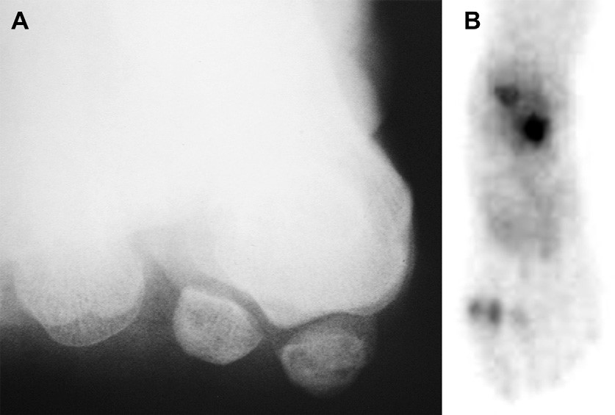
Fig. 3. (A) The forefoot axial view is the preferred projection to evaluate the sesamoid apparatus and the condition of the sesamoid articulations. Here there are numerous cysts within both sesamoids, whereas the morphology of the cristae and the integrity of the sesamoid joint spaces remains intact. It is the entire metatarsal head that is shifted into valgus, maintaining a congruous relationship between the sesamoids and the crista. This condition is a common finding in association with hallux abducto valgus, as opposed to that seen with hallux limitus, in which the sesamoid degeneration is best appreciated in this view. (B) This is the 3rd phase of a triphasic bone scan in a case of sesamoiditis. Notice that the fibular sesamoid appears larger and is more ovoid than the well rounded tibial sesamoid in this case. Focal symptomatology is evident upon direct palpation of the sesamoid apparatus; worse beneath the fibular sesamoid in this 40-year old athlete.

RADIOGRAPHIC EVALUATION AND IMAGING
Generally, weight-bearing radiographs are obtained. The lateral radiograph provides little insight into the condition. An anteroposterior view can sometimes illustrate a bipartite sesamoid or fractures. A medial oblique view is obtained to stress the tibial sesamoid, whereas a lateral oblique view stresses the fibular sesamoid. A sesamoid axial view allows inspection of the sesamoids, cristae, and the position of the sesamoidal apparatus (see Fig. 3A).^{3–5}
When plain radiographs do not suggest deformity or injury ancillary imaging may be warranted. It is understood that the symptoms of a stress fracture in general precede radiographic changes and so nuclear medicine imaging, specifically the 99mTc-MDP scan is reliable in identifying the hyperemia of this condition in advance. In general bone scans have a high sensitivity but low specificity in determining musculoskeletal disease. A dorsal plantar view or posteroanterior bone scan is recommended to distinguish sesamoid disorders from first MTPJ disorders, which can be obstructed in an anteroposterior scan (Fig. 3).⁵ Oblique views of the forefoot best separate the sesamoid from the metatarsal bone and reveal isolated hyperemia within the sesamoid bones using intravenous 99m Tc-methylene diphosphonate (99mTc-MDP). It is also wise to compare a scan of the afflicted foot with the contralateral foot. An increase in uptake in the affected foot compared with the contralateral foot is significant for pathology and suggests injury or active remodeling of bone resulting in hyperemia.³ Although localized sub–first MTPJ pain associated with a sesamoid bone found on plain radiographs to be in two pieces is clinically diagnostic of a fractured sesamoid, a bone scan can be useful when there is a clinical question between what is a bipartite sesamoid and what is a fractured sesamoid. The acute fracture typically has irregular and jagged borders while more chronic inflammatory conditions of a bipartite sesamoid present with rounded margins and well defined borders. Transverse plane separation of the parts or comminution is also suggestive of fracture. Further if the separation of the fragments is large it is more suggestive of fracture than other conditions and contralateral views are particularly important in this instance. Chisin and colleagues⁸ found that 26% to 29% of asymptomatic patients showed increased uptake in the sesamoid region, so nuclear medicine imaging is not necessarily useful in the evaluation of the asymptomatic condition.
A computerized tomography (CT) scan can assist the clinician in diagnosing a stress fracture or nonunion, and can delineate posttraumatic changes compared with the
contralateral part.^{2,4,5} Magnetic resonance imaging (MRI) offers little in the direct diagnosis of sesamoid disorders, but does provide clues to surrounding first MPJ disorders including flexor hallucis tendonitis, plantar plate disorders, osteochondral injury, or gout.² This modality may be useful if attempting to diagnose osteomyelitis of the sesamoid.^{3,5} The senior author has extensive experience with nuclear medicine imaging (NMI) for the evaluation of foot and ankle disorders and has found it especially powerful when investigating musculoskeletal disorders. Even the small and welldefined structures of the forefoot can be resolved using this modality and, in osteomyelitis, this modality is particularly helpful (Figs. 3A and 4C).

SESAMOIDITIS
Sesamoiditis is a generalized term for a painful inflammatory condition associated with a sesamoid complex devoid of radiographic changes. Teens and young adults have a higher predilection for this disorder. Factors that increase susceptibility include a plantar flexed first ray, asymmetry in size, condylar malformation, rotational malalignment, and symmetric enlargement. Physical examination can reveal pain with direct palpation or passive distal push on the sesamoid apparatus, passive dorsiflexion of the hallux, and crepitus along the distal course of the FHL. There may be edema, bursal thickening, and inflammation plantarly (Fig. 5).^{2,4,5}
Conservative treatment for chronic sesamoiditis and most other sesamoid disorders includes rest, ice, nonsteroidal anti-inflammatory medications, and custom modified orthoses. These conditions are often caused by repetitive stress, and correcting any abnormal biomechanical influences is the key to long-term success. This correction can be done in a variety of ways including activity modification, custom modified orthoses, gel inserts under the sesamoids, a metatarsal bar, OrthoWedge shoe, or modified cast immobilization for stress fractures or acute fractures. Bone stimulation can also be used to compliment other conservative treatments when a delayed union or nonunion of sesamoid fracture is suspected. Adjusting custom orthotics to include a Morton extension may be effective, as well as using a carbon fiber forefoot plate to
restrict forefoot motion.^{2,4,5}
Surgical treatment of recalcitrant disorders has been varied. Before the 1980s, excision was the primary treatment.² In 1914, Speed recommended that if 1 sesamoid is excised, then the other should be removed as well to prevent increased pressure on the lone sesamoid.⁸ Subsequently, this led to an increased incidence of cock-up deformity of the hallux and is no longer recommended. However singular excision was advocated for conditions such as displaced and nondisplaced fractures,
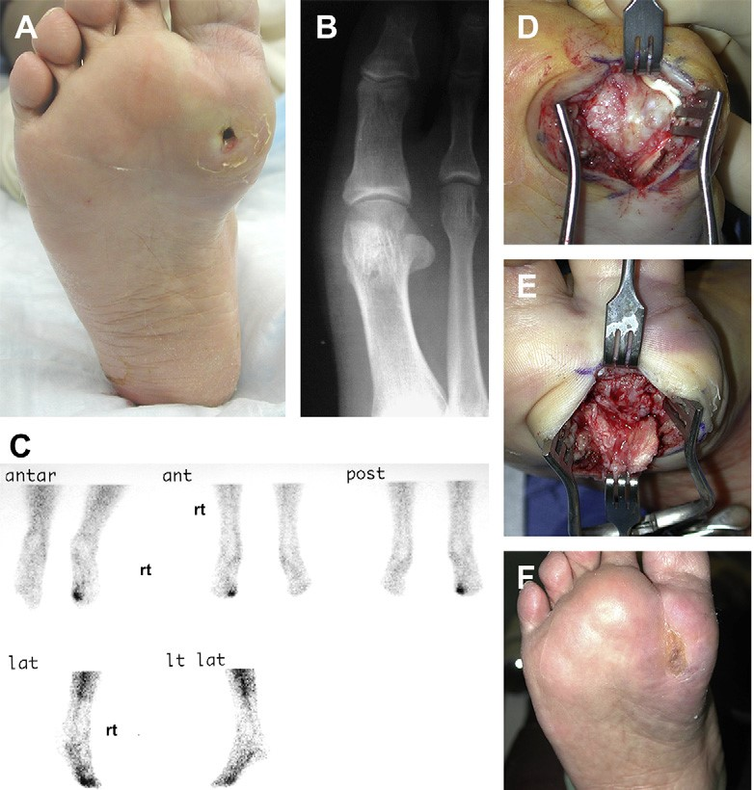
Fig. 4. (A) Chronic sub 1 ulceration associated with uncontrolled diabetes mellitus, peripheral vascular disease, and peripheral neuropathy. The primary care physician had been treating sesamoiditis for 4 weeks until the ulceration developed. This ulceration was hardly noticed by the patient and, were it not for the drainage noted on her socks, she may never have reported this condition. She had been treated with 2 months of oral antibiotics before referral to a foot and ankle specialist. (B) In this plain film, the tibial sesamoid is found to be degenerate with a squared-off medial segment and a multipartite morphology discerned within the lateral half of the bone, reflective of chronic disease. The fibular sesamoid does not appear to be affected by the degenerative process. (C) This example of NMI using 99mTc-monoclonal antibody imaging reveals an infectious process well localized to the plantar aspect of the first MPJ without evidence of extension into the hallux. Given the underlying peripheral vascular disease, it is easy to appreciate that the vascular tree is competent to provide isotope to the entire lower extremity without exception. (D) Squaring of the tibial sesamoid and multipartite lateral half of that bone correlates well with that noted in the plain film (B). (E) Underlying the sesamoid apparatus, the inferior aspect of the first metatarsal head can be appreciated and is found to be degenerate in this region. Excision of the tibial sesamoid and local debridement of the affected inferior surface of the metatarsal head is complimented by intravenous antibiotic therapy for 3-weeks’ duration. This treatment proved to be curative with the benefit of long-term management using custom-molded diabetic insoles and firm-soled, extra-depth shoe gear. (F) Clinical appearance 5 months status after delayed primary closure followed by 3 weeks of intravenous vancomycin adjusted for renal impairment. Long-term management is supplemented by routine follow-up for palliative care of residual keratotic overgrowth. Serologic studies returned to normal baseline parameters immediately after the delayed primary closure and updated serologic testing remains within normal limits more than 4 months after the antibiotic therapy was discontinued.
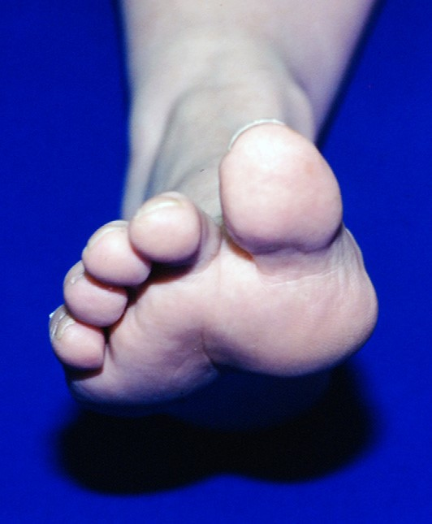
Fig. 5. The clinical appearance of the combination of an inflamed bursal projection and sesamoiditis results in a profound soft tissue enlargement beneath the metatarsal head accentuating the presence of the plantar flexed first ray in this patient.
sesamoiditis or osteochondritis that does not resolve with 6 months of conservative management, and osteomyelitis.⁸ Although isolated sesamoid resection can prove definitive, this procedure is has potential complications. Removing the fibular sesamoid is associated with an increased incidence of hallux varus, whereas removing a tibial sesamoid can worsen a hallux valgus deformity. Excision of either sesamoid can increase the stress or pressure on the metatarsal head and FHL tendon producing localized disorders.² To avoid these complications, alternate surgical procedures have been suggested. Curettage with grafting has been reported for nonunion and AVN.² Aquino and colleagues⁹ reported an 89% subjective success of plantar shaving for intractable plantar keratosis. Open reduction and internal fixation with 2.0-mm screws has been described for displaced acute fractures as well as percutaneous internal fixation for nondisplaced fractures using cannulated screws.² Based upon predictable ill effects, sesamoid excision is reserved as a last ditch effort and often precedes a joint destructive procedure.
The Procedure: Isolated Sesamoid Excision

Four techniques are used depending on the disorder, and include either an intraarticular medial, extra-articular medial, standard dorsolateral, or plantar approach.
An intra-articular medial approach provides the advantage of visualizing and inspecting the MTPJ. This approach begins with a 3-cm to 4-cm incision medially extending from the proximal flare of the metatarsal head to the midshaft of the proximal phalanx. Care is taken to protect the medial plantar nerve in this dissection. A linear capsulotomy is performed just inferior to the abductor hallucis. The plantar capsule, consisting of the retinaculum and metatarsosesamoid ligament can be incised to allow visualization of the tibial sesamoid articular surface as well as the metatarsal head and proximal phalangeal base. At this point, any hypertrophic synovitis can be resected, intersesamoidal ligament tears can be identified, and the condition of the FHL tendon can be assessed. Using this incision, autogenous bone graft could be harvested from the distal portion of the first metatarsal if desired. A beaver blade is commonly used to sharply circumscribe the sesamoids to shell them out of their tendinous investments. Closure consists of 2-0 absorbable suture for plantar capsule repair, 3-0 absorbable suture for reapproximation of the medial capsular incision, and the surgeon’s preference thereafter for the subsequent layered closure.^{2,5}
The extra-articular medial approach is useful for plantar shaving of a hypertrophic or prominent sesamoid or for grafting of a nonunion without an articular step-off. The medial incision is made as previously described. A full-thickness flap is made using a holding suture to elevate the flap off the undersurface of the tibial sesamoid. Care must be taken to protect the FHL tendon at this point. If shaving is to be performed, 30% to 50% of the plantar surface is planed using a saw while rongeuring or rasping is used to recontour the remaining bone. For grafting, if the tendinous expanse surrounding the sesamoids is intact, then displacement of the repair is unlikely, therefore no internal fixation is required.^{2,5}
The dorsolateral approach is used for fibular sesamoid surgery such as repair of a fibular sesamoid fracture and curettage or grafting of a nonunion. Fibular sesamoid excision can also be achieved using this technique; however, it is more easily performed from a plantar incision. A standard 3-cm incision is made in the first intermetatarsal space dorsally. Dissection is similar to that of a lateral intermetatarsal space release used in bunion surgery. The first structure encountered is the deep transverse intermetatarsal ligament (DTIL). After transecting the DTIL, care is taken to avoid damaging the common digital nerve. The adductor hallucis tendon is removed from the proximal phalanx, lateral aspect of the first MPJ capsule, and lateral fibular sesamoid. This tendon is tagged and retracted and later will be re-approximated for repair. Next, a lateral capsulotomy is performed allowing access to the sesamoid apparatus. The intersesamoidal ligament is then identified and incised to liberate the medial aspect of the fibular sesamoid. Great care is taken to avoid damage to the FHL tendon. Once the fibular sesamoid is removed the metatarsal head and phalangeal base are inspected for cartilaginous defects. Associated defects should be drilled or otherwise repaired as necessary. After completing the procedure, the adductor tendon is reattached to the lateral capsule and a layered closure is performed per surgeon’s preference.^{2,5}
The fourth incisional technique is the plantar approach. To avoid the development of a painful plantar scar, the incision is placed beneath the first intermetatarsal space. A curvilinear incision is made extending from the medial portion near the second digit back to the proximal extent of the metatarsal fat pad. After the incision, the lateral plantar digital nerve of the hallux should be identified and protected either just lateral to the sesamoid or over it. The metatarsal fat pad is retracted medially with the nerve and the fibular sesamoid is then sharply excised from the lateral MTPJ capsule and tendinous attachments of the adductor hallucis and the FHB tendon. Once the sesamoid has been excised, a layered closure is performed as per the surgeon’s preference. However, the plantar capsular defect should be closed with 2-0 absorbable
suture.^{2,5}

OSTEOARTHRITIS
Osteoarthritis of the sesamoid apparatus may be secondary to trauma, chondromalacia, chronic sesamoiditis, hallux rigidus, gout, or rheumatoid arthropathy, among other causes.⁵ A common predisposing condition is hallux valgus deformity. As the deformity progresses, the sesamoids become subluxed from the metatarsal and an incongruity occurs within the sesamoid-metatarsal joint. As a result, increased wear on the articular cartilage of the sesamoids and crista evolve and the progression of mechanically induced inflammation leads to degenerative changes which may become symptomatic over time.²

INFECTION
Infection involving the sesamoid complex in healthy patients is rare and often results from direct contiguous seeding from adjacent ulcerations in diabetics with peripheral neuropathy (Fig. 4). Acute hematogenous spread is possible and primarily occurs in children and young adults from the ages of 9 to 19 years.² Treatment of infection includes removal of all infected or potentially infected bone, which can include portions of the metatarsal head or proximal phalanx followed by copious amounts of irrigation and antibiotic therapy is administered based upon the clinical scenario and most often with recommendations from the department of infectious diseases. It is recommended that the surgeon attempts to preserve muscular attachments to prevent a cock-up deformity. When osseous repair is required a staged procedure is planned and the use of internal fixation is delayed until the osteomyelitis is excised or cured. Once the infection is cleared, the hallux can be pinned in plantar flexion for 3 to 4 weeks. A cock-up deformity predisposes the patient to future ulcerations and infections.⁵

INTRACTABLE PLANTAR KERATOSIS
There are numerous causes for intractable plantar keratosis (IPK) of the plantar skin in the region of the sesamoid complex. These lesions may form secondary to structural abnormality of the foot, which includes osteophytosis of the sesamoid complex, dysfunction of the MPJ, a plantar flexed metatarsal, uncompensated forefoot valgus, dorsiflexed second metatarsal, or ankle equinus, among other biomechanical influences (Fig. 6). A more diffuse callus can suggest a slightly larger sesamoid or a muscle
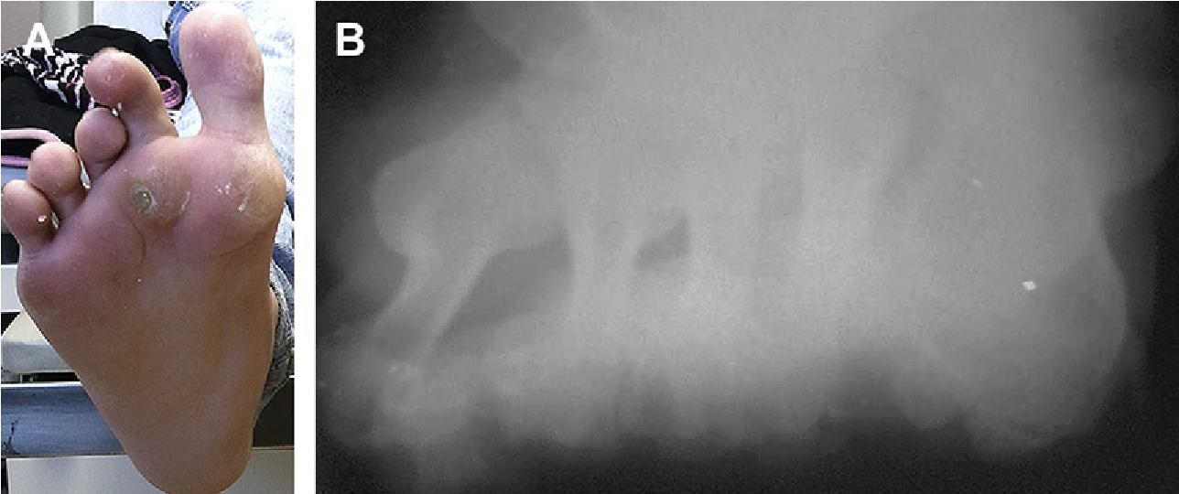
Fig. 6. (A) Note the porokeratosis subfibular sesamoid left and sub 2 right associated with gastrocsoleal equinus and brachymetatarsia 3 to 5 bilateral. This 16-year old girl has suffered the ill effects of long-term steroid use in treating dermatomyositis since the age of 5 years. The degree of ankle equinus after progressive tendon contracture contributes to forefoot imbalance and overload, which is her chief complaint. Note the well-circumscribed fat pads inferior to the metatarsal heads. (B) The forefoot axial view gives optimal appreciation of the deviation of the sub 1 sesamoid apparatus and the lesser MPJ sesamoids sub 2 and 4 that contribute to the lesion pattern in the left foot seen in (A).
imbalance involving the peroneus longus and tibialis anterior or tibialis posterior tendons.⁵ Iatrogenic IPKs can result from plantar flexory osteotomies of the first metatarsal, dorsiflexory or shortening osteotomies of the second metatarsal, excision of a singular sesamoid, and a prior shaving procedure on the neighboring sesamoid.⁴ While these painful keratoses most often occur in active individuals. These discrete lesions can occur in the athlete and nonathlete alike. When present in the face of diabetic peripheral neuropathy these discrete pressure points can result in ulceration, infection and even direct extension of osteomyelitis into the metatarsal head as seen in Fig. 4. Associated soft tissue disorders can be related to IPKs, including a painful bursal sac plantar to the tibial sesamoid (see Fig. 5).²
Conservative treatment in this case may be as simple as periodic paring and accommodative insoles. For lesions failing routine debridement, surgical treatment may be warranted and can include shaving the plantar surface of the sesamoid or complete excision. Shaving should be avoided when there is a plantar flexed first metatarsal deformity, and excision is contraindicated when the plantar flexed metatarsal is nontranslatable or when the metatarsal rests at a level equal to or above the adjacent metatarsal due to the likelihood of recurrence.²

NERVE IMPINGEMENT
The medial or lateral plantar digital nerve can become inflamed for a variety of reasons. The medial plantar digital nerve coursing near the tibial sesamoid becomes irritated because of concomitant hallux valgus deformities as well as overpronation. The lateral plantar digital nerve can be impinged by the fibular sesamoid, but may also produce symptoms of neuritis when the fibular sesamoid is enlarged, displaced, or inflamed itself. Symptoms for nerve impingement include radiating burning pain or numbness distally. Percussion along the route of these nerves with reproduction of the pain can be a telling sign of sesamoid-related nerve impingement.^{2,5} A well placed diagnostic block using a short acting local anesthetic agent can help discriminate musculoskeletal causes from nerve irritation.
Treatment of this disorder can be friction-reducing moleskin padding, a wider toe-box to prevent irritation, ultrasound therapy, and deep manual massage. When recalcitrant pain becomes evident, surgical intervention may be warranted. This intervention can include excision of the offending sesamoid with or without external neurolysis and release of the fascial capsular restraints to decompress the region.⁵

SESAMOID FRACTURE
Fractures of the sesamoid can be either acute or stress related, with each displaying different symptoms and imaging characteristics. Regarding sesamoid fracture, the tibial sesamoid is more likely to be affected. Acute fractures of the sesamoids occur because of excessive cyclic weight-bearing loads or direct trauma. They typically present with a sudden onset of plantar pain after a traumatic episode or with repetitive activities. Radiographs may reveal acute fractures as transverse clefts. Each fragment can be varied in size and amount of displacement. Bony calluses can be seen within 2 to 3 weeks, and bone scintigraphy may become positive within 24 hours.¹
Stress fractures have a slightly different presentation. Onset is generally more gradual and presents after periods of repetitive activity. Radiographic evidence of sesamoidal injury, if it ever manifests, may not be detected for several months. When necessary, CT or MRI can confirm the diagnosis. Stress reactions within the sesamoids share similarities to other stress fractures in bone, but lack the eventual callus formation or obvious cortical disruption. These conditions are nonetheless treated as a stress fracture regarding treatment modalities.¹
Differentiating the acute fracture from bipartite or multipartitite sesamoids, nonunions and malunions can prove challenging. Bipartite sesamoids generally have smooth-contoured edges as opposed to the irregular trabecular patterns seen in fractures, and a sesamoid can be split into 2, 3, or 4 parts with injury (Fig. 2A). It is important to have a high index of suspicion for sesamoid injury or fracture and radiographic comparison with the contra lateral limb is helpful. When the radiographic criteria fit into one of the following categories, the diagnosis of sesamoid fracture is confirmed: (1) an irregular and unequal separation of the affected sesamoid with contours being serrate, (2) evidence of bony callus or attempted healing on serial radiographs, (3) absence of similar radiographic findings in plain films of the contra lateral limb, and (4) surgical treatment with evidence of fracture.²
Complications related to both stress fracture and acute fracture include nonunion, malunions, and AVN. A sesamoid is considered a nonunion at an arbitrary time of 6 months, although a more appropriate definition might include a paucity of healing as shown in serial plain films or in ancillary imaging such as CT, NMI, or MRI. Delayed unions or nonunions are more likely to present when the diagnosis of sesamoid disorders has been delayed or missed altogether. The reasons for a missed or delayed diagnosis can include negative radiographs, misinterpreting the pain as FHL tendinitis or 1st MTPJ capsulitis, and the presence of significant concomitant fore foot injury that confounds its presence or simply a patient’s own benign neglect. Conservative treatment for sesamoid nonunions is the same as that used for a stress. This treatment includes decreased activity, relative rest via soft cast immobilization and walking boot and often periods of complete immobilization. Surgical intervention, which has been shown by numerous investigators to provide better relief of pain compared with conservative treatment, may consist of excision of the sesamoid, partial excision of the affected sesamoidal pole, and bone grafting.¹ Biedert and Hinterman⁶ reported on 5 athletes treated with excision of only the proximal pole of the tibial sesamoid. All 5 athletes returned to activity within 6 months. Anderson and McBryde¹⁰ described using medial eminence autogenous graft for placement in nonunions, and 19 of 21 patients achieved a union and returned to activity. These enhanced and meticulous techniques should not be considered elementary are reserved for the well seasoned foot surgeon.

OSTEOCHONDRITIS AND AVASCULAR NECROSIS (AVN)
This disorder occurs infrequently and is secondary to osseous cell death related to vascular compromise from a varty of conditions. Systemic diseases and medications can be responsible for AVN, but most commonly the culprit is trauma. In the event of trauma (iatrogenic or accidental direct trauma), vascular disruption occurs.¹ Differentiating fracture from avascular necrosis is an important distinction because they can have vastly different long-term outcomes; AVN having the higher incidence of morbidity and dysfunction.
There seems to be a correlation between stress fractures and AVN of the sesamoids. A logical hypothesis is that acute trauma may result in localized disruption to a portion of the vascular supply at the fracture site. The increased marrow edema that results from trauma, prolonged or repetitive weight bearing may lead to widespread ischemia and bone necrosis. Fracture and bony collapse are common sequelae of AVN. AVN of a sesamoid can precipitate a stress fracture, and this explains why they can be recalcitrant to conservative therapy.¹
The diagnosis of AVN can be aided by radiographs; however, these changes can take up to 6 months following the initial onset of symptoms.³ Jahss¹¹ reports radiographic evidence of AVN including early fragmentation, irregularity, and cyst formation. These changes are followed by sclerosis, collapse, flattening, and enlargement of the bone (Fig. 1).¹¹ However, the size of the sesamoids can sometimes make these characteristics difficult to distinguish. To obtain a more accurate diagnosis, a bone scan can be helpful. In the event of an insidious ischemic condition¹⁵ a bone scan reveals a region of decreased isotope uptake, whereas in acute ischemia the surrounding tissues become hyperemic and produce an area of increased uptake. In severe osteonecrosis, the sesamoids do not take up the isotope and a cold spot, or a region of photopenia, becomes evident until revascularization occurs.² When MRI is used for this pathology a T1-weighted image with a normal marrow space has been shown to rule out AVN.¹

THE ROLE OF SESAMOIDS IN HALLUX LIMITUS
Hallux limitus can be debilitating to the patient as it interferes with normal activity and disrupts gait. Generally, it is described as a reduced or absent range of motion usually accompanied by dorsal spurring. Accompanying synovitis or an inflamed bursa may also be present. As mentioned previously, there are numerous and varying causes of hallux limitus or osteoarthritis of the first MPJ. Significant limitation of the 1st MTPJ can result as a consequence of 1st metatarsal elevatus due to trauma or iatrogenic cause. Biomechanical and structural abnormality are culprits for hallux limitus specifically a dorsiflexed first ray, hypermobile first ray, hallux abductovalgus deformity, coalitions within the foot and ankle, a long first metatarsal, and other deformities, have also be associated with the condition. In general the cause of hallux limitus and hallux rigidus is often multifactorial.
The first MPJ is a ball-and-socket joint capable of triplanar motion. In the sagittal plane, the first metatarsal must be capable of plantar flexing and sliding proximally relative to the proximal phalanx. This proximal shift allows the transverse axis to translate dorsally and proximally, which in turn lets the proximal phalanx articulate with the dorsal head of the metatarsal. It is this shift in the transverse axis that allows the first MPJ to increase the range of dorsiflexion during propulsion as opposed to that seen in static stance. Therefore, it is proposed that anything limiting the first metatarsal from plantar flexing or shifting proximally would limit the shift of the transverse axis and ultimately decrease dorsiflexion at that joint.¹²
Durrant and Siepert¹² believe that, to effectively restrict dorsiflexion at the first MPJ, the plantar structures must cross the transverse axis of motion, lie below the transfer axis of motion, attach to the distal hinge or proximal phalanx, exert a force that is parallel to the longitudinal axis of the first metatarsal, and be present on both sides of the longitudinal axis of the first ray. They believe that the sesamoids, FHB, joint capsule, and medial plantar fascial band meet this criterion.¹²
Because of the encasement of the sesamoids in the FHB tendons, it is necessary to understand how each can restrict first MPJ range of motion. The origin of the FHB is on the lateral cuneiform and cuboid and crosses the transverse axis to insert on the proximal phalanx and in doing so it meets all of the criteria described by Durrant and Siepert.¹² The FHB is a stance phase muscle that acts from midstance through the end of propulsion by stabilizing the proximal phalanx against the metatarsal head and ground. Therefore, its anatomic position can limit dorsiflexion if the muscle causes excessive tension against the inferior surface of the metatarsal. This tension happens when the muscle is short compared with the length of the first metatarsal or in the presence of sesamoids. If there is excessive plantar tension, then there is increased stress placed on the dorsal head of the metatarsal by the base of the proximal phalanx, a retrograde force, which, in time, causes bone reactive changes and dorsal spurring.¹² Mann¹³ commented that intrinsic muscles of the foot have to work harder in a pronated foot type during midstance and propulsion, which increases plantar tension. This explains why hallux limitus is commonly associated with a pronated foot type.
The sesamoids have an intricate connection with the FHB tendons because they enhance the pulley action of the tendon and subsequently the muscle’s function. The sesamoid position relative to the first MPJ has not been fully evaluated.¹² According to Root and colleagues,¹⁴ biomechanically the sesamoids assume a more distal position as the first ray plantar flexes and moves posteriorly. The pulley system becomes activated at heel-off, and the first metatarsal head glides proximally on the sesamoid apparatus. In order for this pulley system to operate properly, the sesamoids must be located exactly at the joint where the FHB tendons turn to attach to the proximal phalanx.^{12,14} Problems arise when the sesamoid apparatus is proximally located and fixed as can be seen in later stages of hallux rigidus. This condition has a domino effect on the first MPJ, with a decrease in the plantar flexion and motion of the first metatarsal, which in turn prevents the transverse axis of the 1st MTPJ from moving dorsally and proximally. This limitation of motion prompts dorsal joint abutment and excessive jamming of the proximal phalanx on the metatarsal head.¹² Camasta¹⁵ correlates dysfunction of the 1st MTPJ with a retraction or spasm of the FHB resulting in a proximal position of the sesamoid apparatus; a secondary response to painful arthroses. Initial inferior jamming on the sesamoid apparatus can result in erosive changes along the sesamoid grooves that can be visualized at the time of surgery.¹⁵
Generally, anything that limits first metatarsal plantar flexion eventually leads to hallux limitus. As mentioned previously, proximally displaced sesamoids play a role. However, other sesamoid abnormalities may contribute as well. Elongation of the sesamoids, as occurs due to traction osteophytosis, can prevent plantar flexion of the metatarsal. Bipartite sesamoids, whether congenital or resulting from fracture, are generally longer in the transverse plane of the foot. This morphology results from the excessive pressures of first metatarsal plantar flexion at the time of toe-off. A deep or hypertrophic sesamoid, whether congenital or secondary to osteoarthritis, limits the first metatarsal plantar flexion and sets off the cascade of hallux limitus development.^{12,16}
Most sesmoid pathologies involve chronic inflammation and so there is over lap in these syndromes and so it is important to assess the radiographs and each individual clinical scenario carefully. Sesamoids may contain several characteristics that lead to hallux limitus or hallux rigidus. The natural location of the sesamoid apparatus is predictable as it is deeply invested in its’ fibrocapsular environment and this was proven reported by Judge and colleagues¹⁷ as it related to hallux abducto valgus surgery. The dogma that existed over decades of HAV surgery perpetuated the notion that the sesamoids were released of adhesions and were relocated as a result of HAV surgery. After measuring the position of the tibial sesamoid as it related to the 2nd metatarsal it was statistically established that the sesamoid apparatus in fact does not move and is fixed within its soft tissue environment even as a result of HAV surgery. Consequently it was proven that the translocation of the first metatarsal over the sesamoids is what gives the appearance of sesamoid migration in postoperative films in HAV surgery.
In 1949, Harris and Beath¹⁸ believed the normal distance of the sesamoids from the 1st MTPJ was 12.5 mm to 16.5 mm. Without citing specific values, Yoshioka and colleagues¹⁹ stated that the fibular sesamoid was further from the distal portion of the first metatarsal. Prieskorn and colleagues²⁰ and Hetherington and colleagues²¹ both found mean distances to be shorter than those given by Harris and Beath.¹⁸ Prieskorn and colleagues²⁰ found a mean distance of 4.9 mm of the tibial sesamoid and 7.6 mm of the fibular sesamoid, whereas Hetherington and colleagues²¹ found a mean distance of the tibial sesamoid to be 5.7 mm. Munuera and colleagues²² found values similar to those of Hetherington and colleagues²¹ and Prieskorn and colleagues²⁰ and their data agree with the proposal by Yoshioka and colleagues¹⁹that the tibial sesamoid is located closer to the joint.¹⁶ Roukis and colleagues²³ studied feet diagnosed with hallux rigidus and examined the distance of the sesamoids from the joint. They concluded that there was slight proximal migration of the sesamoids when comparing their data with the normal mean values of Hetherington and colleagues²¹ and Prieskorn and colleagues.²⁰ In a study by Munuera and colleagues²² that examined 183 radiographs, there was no significance found in the distance of the sesamoids from the joint in feet with hallux limitus compared with normal feet. However, there was significance in the length of the sesamoid bones themselves in hallux limitus. No other prior studies had examined sesamoid size in patients with normal and hallux limitus feet.^{16,22} Studies had been performed that examined normal values. Oloff and Schulhofer¹ found the tibial sesamoid to be larger and the fibular sesamoid to be rounder. Yoshioka and colleagues¹⁹ agreed and found the tibial sesamoid in normal feet to be 10.6 mm, whereas the fibular sesamoid was 10.1 mm. Aper and colleagues^{24,25} reported a normal fibular sesamoid to be 13.61 mm.

SURGERY IN THE HALLUX LIMITUS FOOT IN RELATION TO SESAMOID CAUSES
Generally, when evaluating a hallux limitus or rigidus deformity for surgery, the surgeon considers several procedures, usually without taking the sesamoid characteristics into account. Procedures commonly used include simple cheilectomies, first MTPJ arthrodeses, plantar flexory and shortening distal osteotomies, and joint replacement procedures. To have a successful outcome, these procedures should meet certain criteria. Distal osteotomies on the first metatarsal should allow for a stable shortening and an ability to adjust increases in the declination angle of the metatarsal. This osteotomy should allow for ample resection of dorsal cartilage of the first metatarsal head. Also, the plantar cartilage and sesamoidal grooves should be
preserved.^{12,16}
Root and colleagues¹⁴ believed that any osteotomy that shortens the first metatarsal should also plantar flex, which addresses the more proximal location of the sesamoids and the plantar jamming resultant from the virtual lengthening of the plantar intrinsics as the metatarsal is shortened. The combination of these maneuvers allows the sesamoids to translate distally as the 1st MTPJ is put through stance and the propulsive phase of gait. This action concurrently relieves the proximal axial pressure of the proximal phalanx on the metatarsal head. The Youngswick osteotomy has been shown to shorten the metatarsal and plantarflex the metatarsal head and can be used in a metatarsal that is normal length with no hypermobility or dorsiflexion, but with elongated sesamoids.^{12,26} The original Watermann osteotomy, wedge resection of the dorsal metatarsal head rotating the plantar cartilage into the MTPJ, succeeded in shortening the first metatarsal without plantar flexing and seems to be effective when the sesamoids are hypertrophic instead of proximally translocated. Osteotomies can also be performed proximally at the base or shaft and, when needed, a Lapidus procedure can be used to shorten and plantar flex the metatarsal while maintaining range of motion of the first MTPJ.^{12,16}
In selecting the cheilectomy procedure or one of its modifications sesamoid excision may be performed as an adjunctive procedure for grades I & II hallux limitus and the risks associated with that maneuver are well understood. Tagoe and colleagues²⁷ performed a retrospective study on 33 patients with total sesamoidectomy for grade I or II hallux limitus with a normal or even a short first metatarsal. This study reported no complications and favorable subjective outcomes between 2 and 4 years of follow-up. Aper and colleagues²⁵ examined the effect of sesamoid resection on the effective moment arm of the FHB and FHL tendons in cadaveric studies. For the FHB tendon, a significant decrease in the moment arm occurred only when both sesamoids were removed. A significant decrease in the moment arm of the FHL tendon was noted after removal of each sesamoid individually and with total sesamoidectomies. However, no significant change was noted when hemiresections were performed, indicating that partial sesamoidectomy can be performed without significant compromise in the strength of the FHL tendon.²⁴
Controversy still remains concerning the role of the sesamoids in hallux limitus and how these small ossicles should be addressed surgically. A limited amount of evidenced-based literature is available on the matter and even that generally has a low level of evidence. As with most questions regarding sesamoid pathology further evidenced based medicine is required to reconcile controversy in this matter.

ACKNOWLEDGMENTS
Acknowledgment and heartfelt appreciation is extended to the medical library and audiovisual staff members of St Vincent Mercy Hospital Toledo, OH, for assistance in procuring articles and reproducing illustrations.

REFERENCES
- Oloff L, Schulhofer D. Sesamoid complex disorders. Clin Podiatr Med Surg 1996;13(3):497–513.
- Dedmond B, Cory JW, McBryde A Jr. The hallucal sesamoid complex. J Am AcadOrthop Surg 2006;14:745–53.
- Sanders T, Rathur S. Imaging of painful conditions of the hallucal sesamoidcomplex and plantar capsular structures of the first metatarsophalangeal joint. Radiol Clin North Am 2008;46:1079–92.
- Cohen B. Hallux sesamoid disorders. Foot Ankle Clin N Am 2009;14:91–104.
- Richardson E. Hallucal sesamoid pain: causes and surgical treatment. J AmAcad Orthop Surg 1999;7:270–8.
- Biedert R, Hintermann B. Stress fractures of the medial great toe sesamoids inathletes. Foot Ankle Int 2003;24(2):137–41.
- Weil L, Hill M. Bipartite tibial sesamoid and hallux abductovalgus deformity: a previously unreported correlation. J Foot Surg 1992;31(2):104–11.
- Speed K. Injuries of the great toe sesamoids. Ann Surg 1914;60(4):478–80.
- Aquino MD, DeVincentis AF, Keating SE. Tibial sesamoid planing procedure: anappraisal of 26 feet. J Foot Surg 1984;23(3):226–30.
- Anderson RB, McBryde AM. Autogenous bone grafting hallux sesamoid nonunions. Foot Ankle Int 1997;18(5):293–6.
- Jahss MH. The sesamoids of the hallux. Clin Orthop Relat Res 1981;157:88–97. 12. Durrant M, Siepert K. Role of soft tissue structures as an etiology of hallux limitus. J Am Podiatr Med Assoc 1993;83(4):173–80.
- Mann R, editor. Surgery of the foot. St Louis (MO): CV Mosby; 1986. p. 10.
- Root ML, Orien WP, Weed JH, et al. Normal and abnormal function of the foot,clinical biomechanics, vol. II. Los Angeles (CA): Clinical Biomechanics; 1977.
- Camasta C. Hallux limitus and hallux rigidus: clinical examination, radiographicfindings, and natural history. Clin Podiatr Med Surg 1996;13(3):423–48.
- Zammit G, Menz HB, Munteanu SE. Structural factors associated with hallux limitus/rigidus: a systematic review of case controlled studies. J Orthop Sports Phys Ther 2009;39(10):733–42.
- Judge MS, LaPointe S, Yu GV, et al. Hallux valgus surgery and the sesamoidapparatus; a critical statistical analysis. William J. Stickle Gold Award. J Am Podiatr Med Assoc 1999;89(11/12).
- Harris RI, Beath T. The short first metatarsal; its incidence and clinical significance. J Bone Joint Surg Am 1949;31(3):553–65.
- Yoshioka Y, Siu DW, Cooke TD, et al. Geometry of the first metatarsophalangealjoint. J Orthop Res 1998;6:878.
- Prieskorn D, Graves SC, Smith RA. Morphometric analysis of the plantar plateapparatus of the first metatarsophalangeal joint. Foot Ankle 1993;14(4):204–7.
- Hetherington V, Carnett J, Patterson BA. Motion of the first metatarsophalangealjoint. J Foot Surg 1989;28(1):13–9.
- Munuera P, Dominguez G, Lafuente G. Length of the sesamoids and theirdistance from the metatarsophalangeal joint space in feet with incipient hallux limitus. J Am Podiatr Med Assoc 2008;98(2):123–9.
- Roukis T, Jacobs PM, Dawson DM, et al. A prospective comparison of clinical,radiographic, and intraoperative features of hallux rigidus. J Foot Ankle Surg 2002;41(2):76–95.
- Aper R, Saltzman CL, Brown TD. The effect of hallux sesamoid excision on theflexor hallucis longus moment arm. Clin Orthop Relat Res 1996;325:209–17.
- Aper R, Saltzman CL, Brown TD, et al. The effect of hallux sesamoid resection onthe effective moment of the flexor hallucis brevis. Foot Ankle Int 1994;15:462–9.
- Youngswick FD. Modifications of the Austin bunionectomy for treatment of metatarsus primus elevatus associated with hallux limitus. J Foot Surg 1982;21(2): 114–6.
- Tagoe M, Brown HA, Rees SM. Total sesamoidectomy for painful hallux rigidus:
a medium-term outcome study. Foot Ankle Int 2009;30(7):640–6.

